
POSTS AND TELECOMMUNICATIONS INSTITUTE OF TECHNOLOGY
FACULTY OF INFORMATION TECHNOLOGY 1


MAJOR ASSIGNMENT
ANALYSIS AND DESIGN OF INFORMATION SYSTEMS
SUBJECT 32: DESIGN (FULL)

Class: | E22HTTT
Author: | Trần Quang Anh
ID: | B22DCCN044
Mentor: | Đỗ Thị Bích Ngọc

Hà Nội - 2025
Part 1: Requirement 6
1.1. Build the glossary list 6
1.2 Project information 10
1.2.1. Objective of the system 10
1.2.2. Scope of the system 10
1.2.3 How do the modules work 11
1.2.4 Information about objects 12
1.2.5 Relationship between Information Objects 13
1.3. Draw general Use case diagrams and description: 13
1.4. Detail use case diagram (for each function) and description: 15
1.4.1 Modul “Reader Register as a Reader Card” 15
1.4.2 Return documents 16
Part2: Analysis 18
2.1. Scenarios 18
2.1.1. Modul “Reader Register as a Reader Card” 18
2.1.2. Modul “Return Documents” 20
2.2. Extract entity classes and draw entity classes diagram of the system 22
2.3. Extract and draw the class diagram for the modul. 26
2.3.1. Modul ” Reader Register as a Reader Card” 26
2.3.2. Module “Reader Returns Document” 27
2.4. Draw the state diagram for the modul 29
2.4.1 Modul “Reader Register as a Reader Card” 29
2.4.2.Modul “Reader Returns Document” 30
2.5. Write the detailed scenario (ver 2.0). 31
2.5.1 Modul “Reader Register as a Reader Card” 31
2.5.2 Modul “Reader Returns Document” 32
2.6. Draw the communication diagram for the modul. 33
2.6.1. Module “Reader Card Registration” 33
2.6.2 Module “Reader Returns Document” 34
2.7. Draw the sequence diagram for the modul 34
2.7.1 Module “Reader Register as a Reader Card” 34
2.7.2 Module “Reader Returns Document” 35
Part 3: Design 36
3.Entity class diagram (design phase) 36
3.2. Database design for the entire system 37
39
3.3. draw the class diagram for the module 39
3.3.1. Module “register as a reader card” 39
3.3.2. Design module return documents: 41
3.4. Design activity diagrams for the modul 42
3.4.Modul “Register as a reader card” 42
3.4.2 modul “Reader return documents” 42
3.5. Scenario 3.0 43
3.5.1. modul “Register as a reader card” 43
3.5.2. modul “Reader return documents” 43
3.6. Design sequence diagrams for the modul 46
3.6.1. modul “Reader Register as a Reader Card” 46
3.6.2. modul “Reader return documents” 47
3.7 Design Package diagram of the system 48
3.8 Design Deployment Diagram of the system 49
Part 4: Coding 50
4.1 project organization 50
4.2 Interface Image 51
4.2.1 Modul “Reader Register a Reader Card” 51
4.2.2 Modul “Reader Return Documents” 53

Figure list

Figure 1.1. General use case diagram 14
Figure 1.2. Detail use case diagram modul “Reader Register as a Reader Card” 15
Figure 1.3. Detail use case diagram modul “Return documents” 16
Figure 2.1. Entity Class Diagram (Analysis Phase) 25
Figure 2.2. Class Diagram for the “Reader Register as a Reader Card” Modul (Analysis Phase) 27
Figure 2.3. Class Diagram for the “Reader Return Documents” Modul (Analysis Phase) 29
Figure 2.4. State Diagram for the “Reader Register as a Reader Card” Modul 30
Figure 2.5. State Diagram for the “Reader Returns Document” Modul 31
Figure 2.6. Communication Diagram for the “Reader Register as a Reader Card” Modul 33
Figure 2.7. Communication Diagram for the “Reader Return Document” Modul 34
Figure 2.8. Sequence Diagram for the “Reader Register as a Reader Card” Modul 34
Figure 2.9. Sequence Diagram for the “Reader Returns Document” Module 35
Figure 3.1. Entity Class Diagram (Design Phase) 37
3.2. Database Diagram 39
Figure 3.3. Class Diagram for the “Reader Card Registration” Module (DesignPhase) 40
Figure 3.4. Class Diagram for the “Reader Return Documents” Modul (Design Phase) 42
Figure 3.5 Activity Diagram for the “Register as a reader card” modul 42
Figure 3.6 Activity Diagram for the “Reader return documents” modul 42
Figure 3.7. Sequence Diagram for the “Reader Register as a reader card” modul 46
Figure 3.8. Sequence Diagram for the “Reader return documents” modul 47
Figure 3.9. Package Diagram 48
Figure 3.10. Deployment Diagram 49

Subject No. 02
Duration: 90 minutes

A Library management system of a University (LibMan) allows to manage the common documents (books, textbooks, journals, etc.), manage borrowing and returning activities and status performed by students. The system allows:
- Management staff: view statistical reports of status of documents and readers via loan as well as imported documents from suppliers.
- Library staff: manage documents, readers, suppliers (add, delete, change), search, lend documents, receive and return documents from readers, import documents from suppliers.
- Readers: borrow documents, return documents directly to staff, search for document information, register for online reader cards.

Considering two modules and answering questions:
- Reader registers as a reader card: selects the menu to register as a reader card → enters the information of the reader and the card, clicks save → the system saves to database.
- Reader returns documents: selects the menu to receive and return documents → scans the reader's card (or search by code) → selects the documents that the reader brings to return in the list of borrowed documents (additional money fines for damage), late payment (if any) → shows returned invoices → confirms → prints payment slips and deliver to the reader (pay fines if any).

Part 1: Requirement

1.1. Build the glossary list
Table 1.1. Glossary list table
No | Name | Meanings
Group of meanings related to human
1 | Member | A user with an account and authorization to log in to the system and perform permitted functions.
2 | Staff | Refers to all personnel working in the library, including management staff and library staff
3 | Reader | A person who uses the library’s resources and services. Readers are the central users of LibMan and can perform activities like searching for documents, borrowing books, returning them directly to staff. Each reader is required to have a registered reader card that uniquely identifies them in the system. Without a reader card, a person cannot officially borrow or return items.
4 | Management Staff | Higher-level administrators or managers in the library who use LibMan mainly to review and analyze data. Staff who view statistical reports of status of documents and readers via loan as well as imported documents from suppliers
5 | Library Staff | Librarian who manage documents, readers, suppliers (add, delete, change), search, lend documents, receive and return documents from readers, import documents from suppliers
6 | Supplier | An external organization or company providing books, journals, or other documents to the library. Managed in the system for imports and inventory tracking.
7 | Author | The individual or group who creates a work or document, typically with their name printed on the front cover of the document.
Group of meanings related to activity of human
8 | Log in | The essential process required to enter the system. Upon submission of credentials, the platform dynamically presents the relevant interface and activates the appropriate features based on user privileges.
9 | Register Reader Card | The process by which a new reader becomes an official member of the library system. The reader chooses the “Register Reader Card” function in LibMan. They provide personal details. The system validates and saves this information, then issues a unique reader card. Once completed, the reader can use the card to borrow and return items. This process is essential to identify and authorize readers, preventing unauthorized usage of library materials.
10 | Search document | The action of entering a title or code to allow the system to retrieve related documents, enabling users to quickly access essential information about the materials.
11 | Manage document | Actions performed by library staff to maintain document records—such as adding, editing, or removing entries—to ensure accurate and up-to-date information is available to readers.
12 | Borrow Document | The activity in which a reader requests to take a library document (such as a book, textbook, or journal) for a defined loan period. Library staff scan the reader card and the document, and the system records a loan entry with details such as borrow date, due date, and document ID. Once borrowed, the document’s status in the system changes to “On Loan,” making it unavailable to others until returned.
13 | Return Document | The activity where a reader brings back borrowed documents to the library. Staff scan the reader’s card, selects the documents that the reader brings to return in the list of borrowed documents(the return process will be handled per book, not per borrowing record. Partial returns are allowed). The system updates the document status back to “Available.” If the return is late, the system calculates overdue fines automatically. If the document is damaged or lost, additional fees are applied. The return process also generates an invoice that summarizes the returned items and any fines. Once confirmed, a payment slip is printed if fines are involved.
14 | Scan Reader Card | Action of scanning the reader’s card to identify them.
15 | Handling Fines | The procedure carried out by library staff during a reader's book return, involving inspection of the document’s condition and verification of overdue duration to accurately calculate any applicable fines.
16 | Pay Fine | The settlement of penalties applied when a reader returns documents late, damages them, or loses them. The fine is calculated based on library policy ( daily overdue rate and fixed replacement cost). When paying, staff confirm the transaction in LibMan, and the system generates a payment slip as proof. Readers must clear all outstanding fines before borrowing new items. This action maintains fairness and accountability in document usage.
17 | Manage reader | The set of actions performed by library staff to maintain and update information related to readers.
18 | Manage supplier | The set of actions performed by library staff to maintain and update information related to suppliers
19 | Manage staff | The actions performed by management staff to oversee active library personnel, track working hours, and calculate salaries.
20 | View statistics | The action performed by management staff to access key information objects that have been analyzed and presented through visually organized data.
21 | View document statistics | The action performed by management staff to view statistical data related to documents, including borrowing frequency and other key metrics.
22 | View author statistics | The action performed by management staff to view statistical data related to authors, including the number of documents and other relevant metrics.
23 | View reader statistics | The action performed by management staff to view statistical data related to readers, including borrowing frequency, violation counts, and other key performance indicators.
Group of meaning related to objects and system functions
24 | Document | In LibMan, a “document” is any item that can be cataloged, borrowed, or tracked: books, textbooks, journals, research papers. Each document has multiple copies, and each copy has its own code.
25 | Reader Card | The card issued when a reader registers. In business practice, the card is scanned at every borrowing or returning transaction. Without a valid card, the system cannot identify the user and the transaction cannot proceed. The card therefore acts as the gateway for all LibMan operations, linking human activity to digital records.
26 | BorrowingSlip | A confirmation document that verifies which materials a reader has borrowed and at what specific time.
27 | ReturnSlip | A printed receipt that confirms which documents a reader has returned and at what specific time.
28 | Payment Slip | After a fine is paid, LibMan prints a payment slip. It includes reader ID, items involved, fine amount, and payment date. The slip is given to the reader as proof of payment and stored in the system for audits.
29 | Database | The backend storage that supports every scenario. For example, when borrowing a book, LibMan retrieves the reader’s record and updates the loan table. When searching, the system queries the document catalog. When generating reports, it aggregates transaction data. Without the database, no scenario could run.

1.2 Project information

1.2.1. Objective of the system
The LibMan web system supports library management, enabling readers to search for document information and register for reader cards online; assisting library staff in managing information related to documents, readers, and suppliers, as well as handling borrowing and returning procedures; and helping management staff manage general information (accounts, library staff) and view statistical reports.

1.2.2. Scope of the system
- Member of the system
  - Login
  - Logout
  - Change personal password
  - Update personal information
- Reader (Student)
  - Perform all member functions
  - Register for a reader card online
  - Borrow documents and return them directly to staff
  - Search for document information
- Library Staff
  - Perform all member functions
  - Manage documents (add, delete, edit)
  - Manage readers (create, update, deactivate)
  - Manage suppliers (add, delete, update)
  - Search for document information
  - Lend documents to readers
  - Receive documents from readers, including applying fines for late returns or damages
  - Import documents from suppliers
- Management Staff
  - View statistical reports on:
    - Document status (available, borrowed, damaged, etc.)
    - Reader activity (borrowing rates, overdue patterns)
    - Imports from suppliers

1.2.3 How do the modules work
- Reader registers for a reader card
  - Reader logs into the system-> select the Register reader card function.
  - The system presents a form to enter information-> Reader enters required information (name, date of birth, address, email, phone, username, password)
  - Reader click Save -> system validates data (no duplicates, required fields filled, ID valid)
  - The system displays the information that the user has filled in the form and has a confirmation button-> The reader click confirm
  - system create a reader record, reader Card record is saved into system, generate Card ID + QR code, set status = Active
  - The system returns to the main interface.
- Reader returns documents
  - Library staff logs into the system→ selects the Receive & Return Documents function
  - Staff scans the reader’s card (QR code or search by reader ID) -> system shows the list of documents currently borrowed by that reader
  - Staff selects the documents the reader is returning, When selected, the documents will fall into the list of products being returned
  - Staff select document in list of products being returned to check for overdue items (system calculates late fine)-> Staff inspects items → if damaged, enters option damage and notes(system calculates damage fine depend on option damage staff choose)
  - System generates a Return Invoice with list of returned items, due dates, days overdue, late fines, damage fines, and total payment
  - Staff confirms transaction → system updates loan records (status = Returned, return_date), updates item copy status (Available or Repair), creates fine record if any.
  - System generates a Payment Slip → printed and delivered to the reader.
  - Reader pays the fine if required.
  - System returns to the staff main interface.

1.2.4 Information about objects
People-related objects
- Member: member_id, username, password_hash, full_name, date_of_birth, email, phone_number, status
- Reader (extends Member): reader_id, card_id, enrollment_year, status (Active/Suspended/Expired)
- Library Staff (extends Member): staff_id, position (circulation, acquisitions, …)
- Management Staff (extends Library Staff): role (manager, director, …)
Document-related objects
- Document: document_id, title, author, ISBN_or_ISSN, type (book, journal, …), edition, publisher, year, subject
- Item Copy: copy_id, document_id (FK), barcode, condition, status (Available/OnLoan/Damaged/Repair/Withdrawn), location_shelf
Supplier-related objects
- Supplier: supplier_id, name, address, contact_info, status
- Import Shipment: shipment_id, supplier_id (FK), invoice_number, received_date, total_cost, status
- Import Shipment Line: shipment_id (FK), document_id , quantity, unit_cost
Circulation objects
- Loan: loan_id, reader_id (FK), copy_id (FK), checkout_date, due_date, return_date, status (OnLoan/Returned/Lost)
- Fine: fine_id, type (Late/Damage), amount,
- Fine Detail: finedetail_id, returnitem_id (FK), fine_id(FK), amount
Process-generated documents
- Loan: loan_id, reader_id (FK)
- Loan item: loanitem_id, copy_id(FK), loan_date, due_date, status
- Return Invoice: invoice_id, reader_id (FK), staff_id (FK), total_amount, status
- Return Item: invoice_id, loan_id(FK), return_date
Report/Statistics objects
- Loan statistics: active loans, overdue counts, trends
- Reader statistics: borrowing activity, fines
- Document statistics: most borrowed, by category/subject
- Supplier/Import statistics: shipments, costs, supplier ranking

1.2.5 Relationship between Information Objects
- A Document have many Copy
- A Reader has many Loan.
- A Library Staff member handles many Loan.
- A Loan has one or more Loan Items .
- A Loan Item have one Copy.
- A Reader has many Return Invoice.
- A Library Staff member handles many Return Invoice.
- A Return Invoice has one or more Return Items.
- A Return Item have one Loan Item
- A ReturnItem have many FineDetails
- A FineDetail have one Fine.
- A Library Staff member handles many Import Invoice.
- A Supplier issues many Import Invoices.
- An Import Invoice contains many Copy.

1.3. Draw general Use case diagrams and description:
General use case diagram (for the whole system):
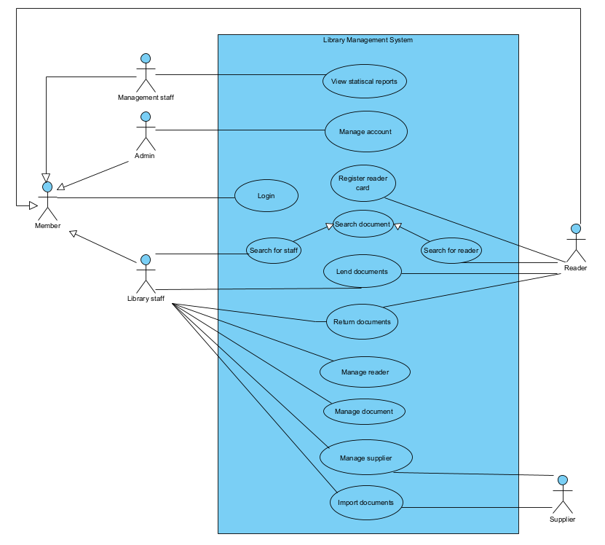

Figure 1.1. General use case diagram
Description:
- Log In : This usecase allows a system member to log in and use the system functions appropriate to their role.
- View Statistical reports : This usecase allows management staff to view statistical reports: document statistics by number of loans, reader statistics by number of loans, supplier statistics by import quantity, etc.
- Search Documents (Reader Side): This usecase allows the reader to search for document information and view the document information displayed to the reader.
- Search Documents (Staff Side) 764: This usecase allows the Library Staff to search for document information and view the document information displayed to the Library Staff.

- Register reader card : This usecase allows the reader to submit an online request for a reader card to the library via the website.
- Lend Documents: This usecase allows the Library Staff to perform the procedures for lending documents to the reader based on the corresponding reader's request.
- Return Documents: This usecase allows the Library Staff to perform the procedures for receiving borrowed documents returned by the corresponding reader.
- Manage Document : This usecase allows the Library Staff to perform management operations on documents: adding, deleting, and modifying.
- Manage Reader : This usecase allows the Library Staff to perform management operations on readers: adding, deleting, and modifying.
- Manage Supplier: This usecase allows the Library Staff to perform management operations on suppliers: adding, deleting, and modifying.
- Import Documents: This UC allows the Library Staff to perform the importing of documents from the corresponding supplier.

1.4. Detail use case diagram (for each function) and description:

1.4.1 Modul “Reader Register as a Reader Card”

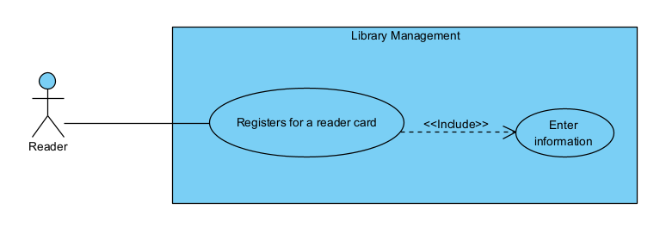

Figure 1.2. Detail use case diagram modul “Reader Register as a Reader Card”
Description:
- Register for a Reader Card
  - Description: Allows a reader to register for a new reader card by entering personal and card information, validating the data, and saving it into the system.
- Enter Information (<<include>>)
  - Description: Allows the reader to enter required personal information and card details into the registration form.

1.4.2 Return documents
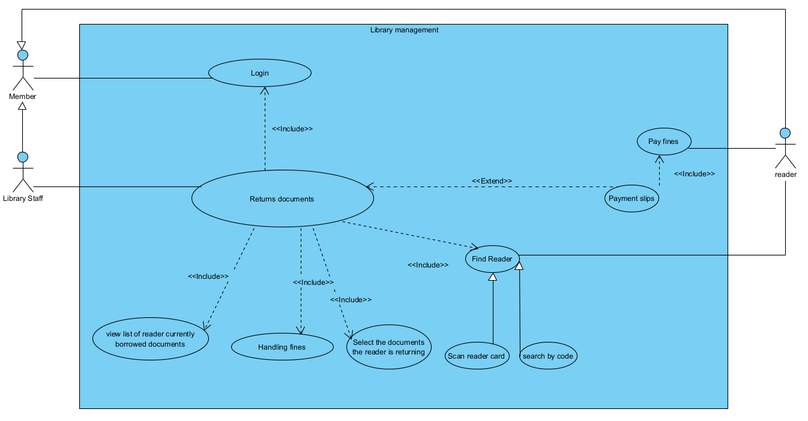

Figure 1.3. Detail use case diagram modul “Return documents”

Description:
- Return Documents
  - Description: Allows library staff to process the returning of borrowed documents, including checking fines and printing slips.
- Login (<<include>>)
  - Description: Allows staff to authenticate before accessing system functions.
- Find Reader (<<include>>)
  - Description: Allows staff to identify the reader who is returning documents.
  - Specialization:
    - Scan reader card.
    - Search by code.
- View List of Reader’s Currently Borrowed Documents (<<include>>)
  - Description: Displays the list of documents currently borrowed by the reader.
- Select the Documents the Reader is Returning (<<include>>)
  - Description: Allows staff to select which borrowed documents are being returned.
- Handling fines (<<include>>)
  - Description: handling fine information: late fine, damage fine that document is chosen
- Pay Fines (<<include>>)
  - Description: Allows the reader to pay fines for late or damaged documents.
- Print Payment Slip (<<extend>>)
  - Description: Prints the payment slip to be delivered to the reader after return confirmation.

Part2: Analysis

2.1. Scenarios

2.1.1. Modul “Reader Register as a Reader Card”

Usecase | Register for a Reader Card
Actor | Reader
Pre-condition | The reader does not already have an active reader card
Post-condition | A new reader card is created, stored in the system, and marked as Active.  The reader can use the card for borrowing and returning documents.
Main Scenario | 1.From the main interface, the reader selects the function Register Reader Card.  2.The system displays the registration form (fields: name, date of birth, address, email, phone, student ID)  Name Tran Van A  date of bith 11/2/2004  address 178@ address B  email studentA@gmail.com  phone number 0908002348  username tranvanahaha  password 123456@  3.The reader enters all the required personal information and click Save button.  4.The system displays the entered information and provides a Confirm button.  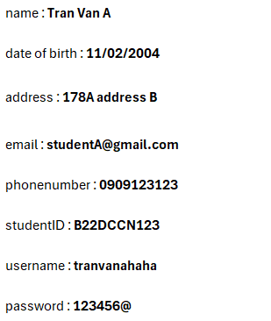  5.The reader clicks Confirm.  6.The system generates a reader record, creates a reader ID + QR Code, and sets the card status = Active, The system notify register card successfully  7. The reader clicks Back To Menu  8.The system returns to the main interface.
Exception | 3a. Missing or invalid information → The system shows an error and requests correction.  3b. Duplicate or invalid reader ID,username → The system cancels the registration and notifies the reader.

2.1.2. Modul “Return Documents”
Usecase | Return Documents
Actor | Library Staff, Reader
Pre-condition | The reader has borrowed documents that are not yet returned.  The library staff has successfully logged into the system.
Post-condition | The reader returned documents successfully  The returned documents are updated in the system with status Available.  If fines exist, a payment slip is generated and delivered to the reader.
Main Scenario | 1.Library staff logs in and selects the Receive & Return Documents function.  2. The system display find reader interface:  - a search box readerID  - A find button  - Qr code scan button  3.Staff receive reader card from reader,searches reader ID “RD-06cde4b5”and click search.  4. The system display update result the reader is chosen:  reader ID RD-06cde4b5  readerID reader name status choose  RD-06cde4b5 Vũ Thị Phương active Click  5. Staff choose that reader.  6.The system displays borrow list interface:  - Reader information: full name: Vũ Thị Phương, readerID: RD-06cde4b5  - the list of documents currently borrowed by the reader.  LoanItemID Document Title Loan Date Due Date Barcode Choose  LIT-82e2 Java cơ bản 03-09-2025 07-09-2025 BAR43e9 Click  LIT-be23 Thiết kế hệ thống thông tin 03-09-2025 07-09-2025 BAR966e Click  7.Staff receive document from reader 1 copy: Java cơ bản and click Choose the documents that the reader is returning.  8. The system notify that this document the reader choose is selected  (repeat 7-8 step to choose enough book to return)  9.Staff click Return Basket button  10.The system display the list of document being returned:  - Processing return document: loanItem id(LIT-82e9), document title(Java cơ bản), loan date (03-09-2025), due date (07-09-2025)  - Latefine line, empty damage fine table, choose damage button, and continue button.  11.Staff inspects the document; if damaged, choose Damage button.  12.The system display the list of damage fine.  Fine ID Reason Cost/Unit Level Level Action  FINE-0b3eb022 Lost Cover 50000 1 Click  FINE-35d87 Torn Pages 20000 1 Click  13. Staff choose the damage fine and click Save.  14. The system return to the list of document being returned interface.  (Repeat step 11-14 in every documents)  15. Staff enter Continue.  16.The system generates a Return Invoice showing returned documents, due dates, overdue days, late fines, damage fines, the total payment, and confirms button.  17.Staff confirms the transaction.  18.The system generates a Payment Slip interface and prints button and Confirm payment button.  19. Staff request reader pay the fine if have  20. Reader pay fine to staff  21. Staff click confim payment and choose print  22. System print payent slip successfully  23. Staff deliver payment slip to reader and click Back to Main button  24.The system returns to the staff’s main interface.
Exception | 3a. Reader not found → The system shows an error.  6a. No borrowed documents found → Return process cannot continue.  b. Lost document reported → The library chooses the document lost. The system applies a fine for the lost document.  20a. Reader refuses or fails to pay fines → Payment remains pending with status = Unpaid.

2.2. Extract entity classes and draw entity classes diagram of the system
Step1: System Description
The Library Management System (LibMan) is a multifunctional web-based application designed to manage and optimize the operations of a university library. The system provides role-based access and features, tailored to different types of users, including management staff, library staff, readers, and suppliers. Management staff have the ability to view and oversee statistical reports of the status of documents and readers via loan, such as the borrowing frequency of different types of documents, borrowing activities of readers, and imported documents from suppliers. Library staff can manage documents, readers, and suppliers by adding, deleting, and updating records, as well as searching for documents, lending and receiving returned documents, and importing documents from suppliers. In return function, they also handle the processing of return invoices, payment slips, and fines in cases of overdue or damaged documents. Readers are able to borrow and return documents, search for document information, and register online for reader cards.
Suppliers provide documents to the library, ensuring continuous updates and availability of resources. By integrating these functions, LibMan enhances efficiency, transparency, and user experience in library management.
Step 2: Extracted Nouns from the System Description
- Nouns related to people:Management staff, Library staff, Readers, Suppliers, Administrators,
- Nouns related to physical objects: Library, Documents (books, textbooks, journals, learning materials), Reader card (electronic), Copies of documents, Supplier-provided resources
- Nouns related to information/data: Borrowing slip, ImportInvoice, List of borrowed documents, Reader card information, Return invoice, Payment slip, Fine, Statistical report, User account, System database.
Step 3: Evaluate and Select Nouns as Entity Classes or Attributes
- Abstract nouns: System, statistical report, information → discard
- People-related nouns:
  - System member → class Member (Abstract): fullName, username, password, address, date, email, phoneNumber, role,note
  - Reader → class Reader, inherits from Member, add : validFrom, validTo, status, qrCode
  - Staff → class Staff (abstract): inherits from Member, adds attribute: salary, staffRole, hireDate
  - Supplier → class Supplier: name, tax code, email, phone, address
- Object-related nouns:
  - Document → class Document:, title, type, author, publisher, publishDate
  - Copy of document → class Copy: barcode, status, condition, location
  - Information-related nouns:
  - Borrowing slip → class Loan: staff, document, reader, loan at, due date, status
  - Invoice Return→ class ReturnInvoice: staff, date, fine, reader, document, total amount, create at
  - Fine → class Fine: amount, reason, type.
  - Reader statistics → class ReaderStatistics (optional reporting entity, can be discarded as abstract)
  - Import Invoice -> class ImportInvoice : supplier , staff, import date, status
Step 4: Determine multiplicities between entities
- A document has many copies, each copy belongs to exactly one document -> relationship between Document and Copy is 1 - n
- A reader have one reader cards -> relationship between Reader and ReaderCard is 1-1
- A reader can borrow many copies through loans -> relationship between Reader and Loan is 1-n
- A loan has many loan items(each for one copy) -> relationship between Loan and LoanItem is 1-n
- A loan item corresponds to one copy -> relationship between LoanItem and Copy is 1-1
- A library staff member can issue many borrowing slips -> relation between LibraryStaff and Loan is 1-n
- A library staff member can issue many invoices -> relationship between LibraryStaff and ReturnInvoice is 1-n
- A return invoice has many Return item → relationship between ReturnInvoice and ReturnItem is 1–n
- An return item may generate many fine → relationship between InvoiceItem and Fine is 1-n
- An invoice have one payment→ relationship between ReturnInvoice and Payment is 1–1
- A supplier can provide many import invoices → relationship between Supplier and ImportInvoice is 1–n
- An import invoice has many import items → relationship between ImportInvoice and ImportItem is 1–n
- An import item refers to one document and may create many copies → relationship between ImportItem and Copy is 1–n
- A manager can view many document statistics → relationship between Manager and DocumentStatistics is 1–n
Step5: Object relationships between entities
- Copy is a component of Document → composition.
- Type is a component of Document → composition.
- Name is part of Member → composition.
- Reader Card inherit from Reader → inheritance.
- Staff Inherit from Member → inheritance.
- Management Staff inherit from Staff → inheritance.
- Library Staff inherit from Staff → inheritance.
- LoanItem is a component of Loan → aggregation.
- Reader is a component of Loan → aggregation.
- Library Staff is a component of Loan → aggregation.
- Copy is a component of LoanItem → aggregation.
- ReturnItem is a component of ReturnInvoice → aggregation.
- Reader is a component ofReturn Invoice → aggregation.
- Library Staff is a component of ReturnInvoice → aggregation.
- Copy is a component of ReturnItem → aggregation.
- Return Item associate to Fine create Fine Detail → association.
- Payment is a component of Return Invoice → composition
- Import Item is a component of Import Invoice → aggregation.
- Library Staff is a component of Import Invoice → aggregation.
- Supplier a component of Import Invoice → aggregation.
- Copy is a component of Import Item → aggregation.

The result comprehensive Entity Class Diagram in the Analysis Phase of the System is presented in the figure below:
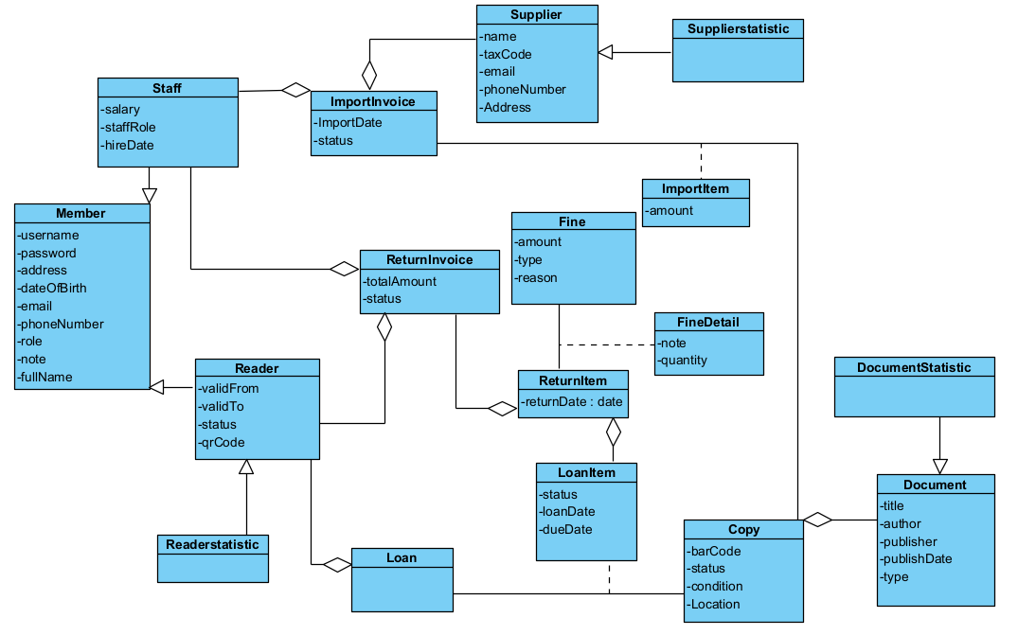

Figure 2.1. Entity Class Diagram (Analysis Phase)

2.3. Extract and draw the class diagram for the modul.

2.3.1. Modul ” Reader Register as a Reader Card”
- Initial, the reader’s main interface -> propose class ReaderHome, needs:
  - SuRegisterCard : submit.
- register card form interface -> propose class RegisterCardForm
  - Inputs: inFullName, inDob, inAddress, inEmail, inPhoneNumber, inUsername, inPassword
  - Outputs : outErrors
  - Submits : subSave, subBack
  - check validation in Reader information, need to process in system:
    - input: reader
    - output: boolean
  - recommend checkValidate(), add to Reader
- Confirm card registration interface -> propose class ConfirmRegistration
  - Outputs: outEnteredInfoSummary
  - Submits: subConfirm
  - Create reader:
    - input: name, dob,address, email, phone, studentID
    - output: Reader
  - recommend createReader(), add to Reader
- Result interface -> propose class ResultRegistration
  - Outputs: outReaderID, outQRCode
  - Submits: subBackToMain
  - To have QrCode, need to process in system:
    - Find Reader Infomation:
      - Input: username
      - Output: Reader
  - recommend getReaderInfo(), add it to Reader.
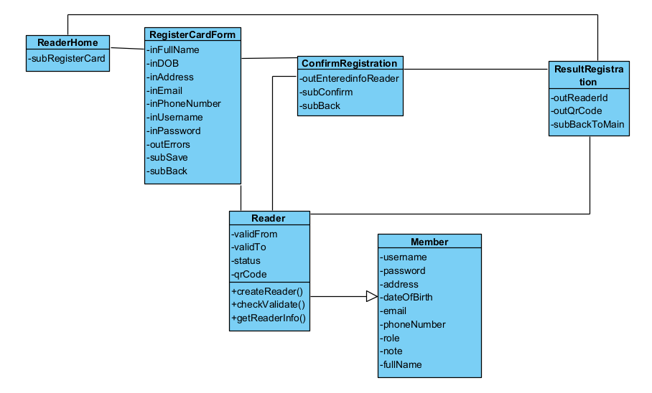

Figure 2.2. Class Diagram for the “Reader Register as a Reader Card” Modul (Analysis Phase)

2.3.2. Module “Reader Returns Document”
- StaffHome
  - subReturn (submit: open Receive & Return)
  - FindReader
  - inreaderId (input)
  - outReaderInfo (output)
  - outError (output)
  - subSearchReader (submit)
  - subChoose(submit)
  - To find reader by readerID, need to proceed in system:
    - input: readerId
    - output: Reader
  - ->Recomend findByReader(readerId), add to Reader
- BorrowdList
  - outBorrowedItemsTable (output: list of open loans per copy)
  - subSelectedForReturn(LoanItemID)(submit: add selected copy/copies to the ReturnBasket)
  - subReturnBasket(submit: show the selected items being returned)
  - To find LoanItem that reader borrowed, need to process in system:
    - input: readerId
    - output: List<LoanItem>
  - Recommend getLoanItemByReader(readerId), add to LoanItem
- ReturnBasket
  - outSelectedItemsTable(output: documents chosen to return, with ,loan date, due date, days overdue, current fines)
  - subAddDamage (submit: open damage selector for an item)
  - outLineFineLate (output)
  - outLineFineDamage(output)
  - outListTotalFine(output)
  - outLineTotal(output)
  - subContinueToPreview (submit)
  - To get late fine:
    - output: fine
  - Recommend getLateFine, add to Fine
- DamageFine
  - outFineTable(output: list all damage fine )
  - subChooseFine(submit)
  - subBack(submit)
  - subSave(submit)
  - To get damage list:
    - output: List<Fine>,
  - Recommend ListDamageFine(), add to Fine
- ReturnInvoice
  - outReaderInfo(output)
  - outReturnItems (output: returned items, due dates, overdue days, latefine, damage fine, totals)
  - outTotalAmount (output)
  - subConfirmReturn (submit)
  - Recommend createReturnInvoice, add to ReturnInvoice
- PlaymentSlip
  - outReaderInfo(ouput)
  - outStaffInfo(output)
  - outReturnItems
  - subPrintSlip(submit)
  - subConfirmPayment(submit)
  - subBackToMain(submit)
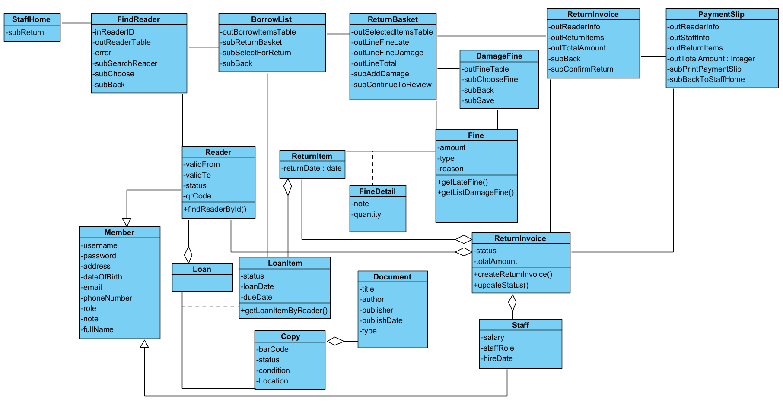

Figure 2.3. Class Diagram for the “Reader Return Documents” Modul (Analysis Phase)

2.4. Draw the state diagram for the modul

2.4.1 Modul “Reader Register as a Reader Card”
Form the main interface, if the Register Reader Card function is selected, the system moves to the registration form interface (RegisterCardForm)
At RegisterCardForm, when information is entered and saved is clicked:
- If the data is valid -> the system moves to the confirmation interface(ConfirmRegistration)
- If there are errors, missing fields or duplicate reader -> stay atRegisterCardForm and show validation messages.
At ConfirmRegistration, when Confirm is clicked: the system moves to the result interface(ResultRegistration)
At ResultRegistration, when Back to Main is clicked: go back to main interface
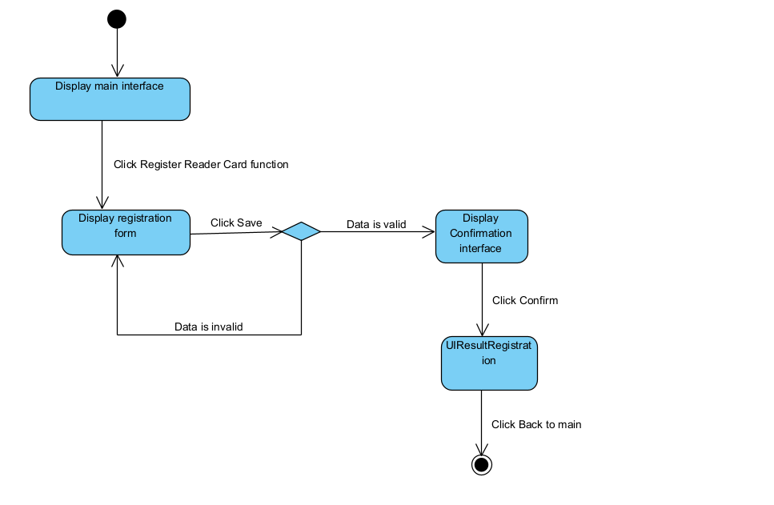

Figure 2.4. State Diagram for the “Reader Register as a Reader Card” Modul

2.4.2.Modul “Reader Returns Document”
From StaffHome , if Receive & Return Documents is selected → go to FindReader interface.
- At FindReader interface, when Search is clicked:
  - [reader found] →show reader information and choose this reader -> go to BorrowList; [not found] → stay and show error;
- At BorrowedList
  - when items are Selected for Return → add them to the basket
  - when click to Return Basket -> go to ReturnBasket
- At ReturnBasket, the system checks due dates & computes late fines for document being returned
  - Add Damage → open damage selector; choose damage → update fines on that item;
  - Continue → go to ReturnInvoicePreview;
- At ReturnInvoicePreview, when Confirm is clicked→ go to PaymentSlip
- At UIPaymentSlip, when Print (optional) and Back to Main are clicked → go to Staff Main.
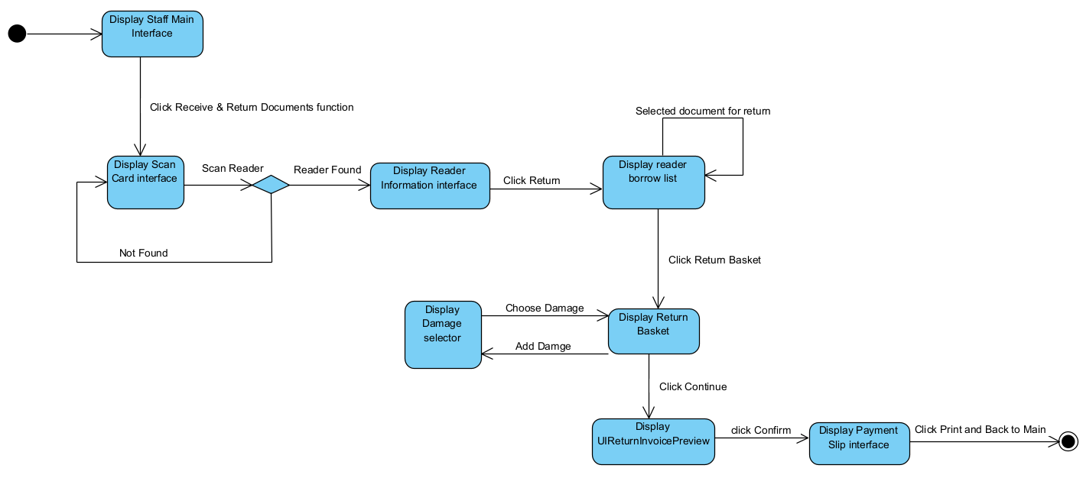

Figure 2.5. State Diagram for the “Reader Returns Document” Modul

2.5. Write the detailed scenario (ver 2.0).

2.5.1 Modul “Reader Register as a Reader Card”
- At the reader's main interface after logging in, the reader clicks Register Card.
- The ReaderHome class calls the RegisterCardForm class.
- RegisterCardForm displays the form for entering personal information.
- The reader fills in all required fields and clicks Save.
- RegisterCardForm calls the Reader class.
- The Reader class performs data validation checks.
- The Reader class returns the result to RegisterCardForm.
- RegisterCardForm calls the ConfirmRegistration class.
- ConfirmRegistration displays the summary information for confirmation.
- The reader clicks Confirm in ConfirmRegistration.
- ConfirmRegistration calls the Reader class to create a new reader.
- The Reader class creates a new reader record and generates a ReaderCode.
- The Reader class returns the new reader object to ConfirmRegistration.
- ConfirmRegistration calls the ResultRegistration class to display the registration result.
- ResultRegistration calls the Reader class to retrieve the reader card information that was just created.
- The Reader class finds and retrieves the card information.
- The Reader class returns the card information (CardID, QR Code, CardStatus) to ResultRegistration.
- ResultRegistration displays the successful registration result to the reader.
- The reader clicks Back to Main.
- UIResultRegistration calls the ReaderHome class.

2.5.2 Modul “Reader Returns Document”
- At the staff main interface after login, the staff clicks Return documents.
- StaffHome calls FindReader.
- FindReader display to the staff.
- staff enter the reader ID and search
- FindReader calls Reader to find the reader by ReaderID.
- Reader searches for the reader information in the database.
- Reader returns the result to FindReader.
- FindReader display the reader’s information.
- Staff click to the reader is searched
- FindReader calls LoanItem to request the list of documents currently borrowed by the reader.
- LoanItem retrieves the list of unreturned documents from the database
- LoanItem returns the result to FindReader.
- FindReader calls BorrowList.
- BorrowList displays the list of borrowed documents to the staff.
- The staff clicks Choose.
- loanItem update borrowed documents to documents being returned and display to staff
- Staff click ReturnBasket button
- BorrowList call ReturnBasket.
- ReturnBasket calls Fine to get late fines.
- Fine retrieves late fines from the database
- Fine returns the late fine to ReturnBasket.
- ReturnBasket displays the Item being returned and Overdue Fine.
- The staff chooses DamageFine.
- ReturnBasket calls Fine to request the list of damage types.
- Fine generates the list of damage types and damage fees.
- Fine returns the list of damage types and fees to ReturnBasket.
- ReturnBasket call DamageFine
- DamageFine displays the Damage Fine Selector.
- The staff chooses a damage fine and clicks Save.
- DamageFine call ReturnBasket
- ReturnBasket displays the updated Return Basket.
- The staff clicks Continue.
- ReturnBasket calls ReturnInvoice.
- ReturnInvoice displays the total information to the staff.
- The staff clicks Confirm.
- ReturnInvoice interface call ReturnInvoice to create transaction to database
- ReturnIvoice create a transaction
- ReturnInvoice return result to ReturnInvoice interface
- ReturnInvoice call PaymentSlip
- PaymentSlip display to Staff
- Staff click Confirm Payment
- PaymentSlip call ReturnInvoice
- ReturnInvoice update status the invoice to “PAID”
- ReturnInvoice return result to Payment interface
- PaymentSlip display to the staff
- The staff clicks Print.
- PaymentSlip displays the payment slip.
- The staff clicks Back to Main.
- PaymentSlip calls StaffHome.

2.6. Draw the communication diagram for the modul.

2.6.1. Module “Reader Card Registration”
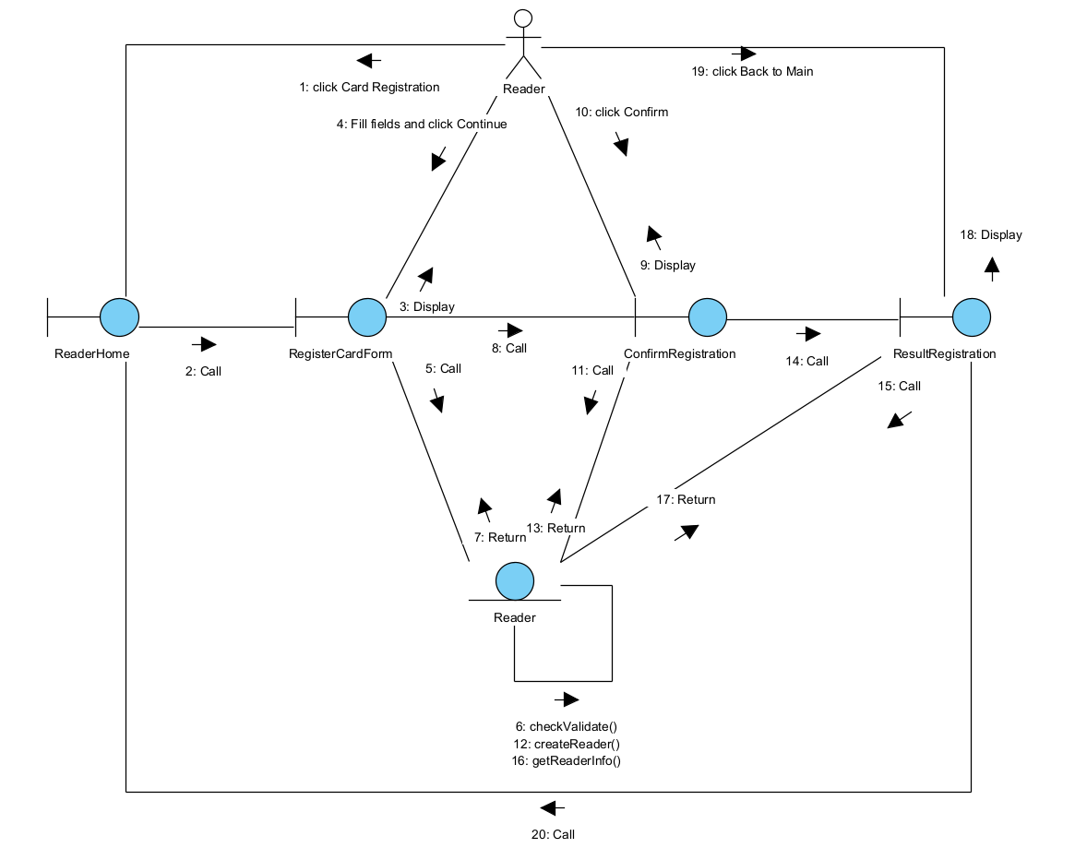

Figure 2.6. Communication Diagram for the “Reader Register as a Reader Card” Modul

2.6.2 Module “Reader Returns Document”
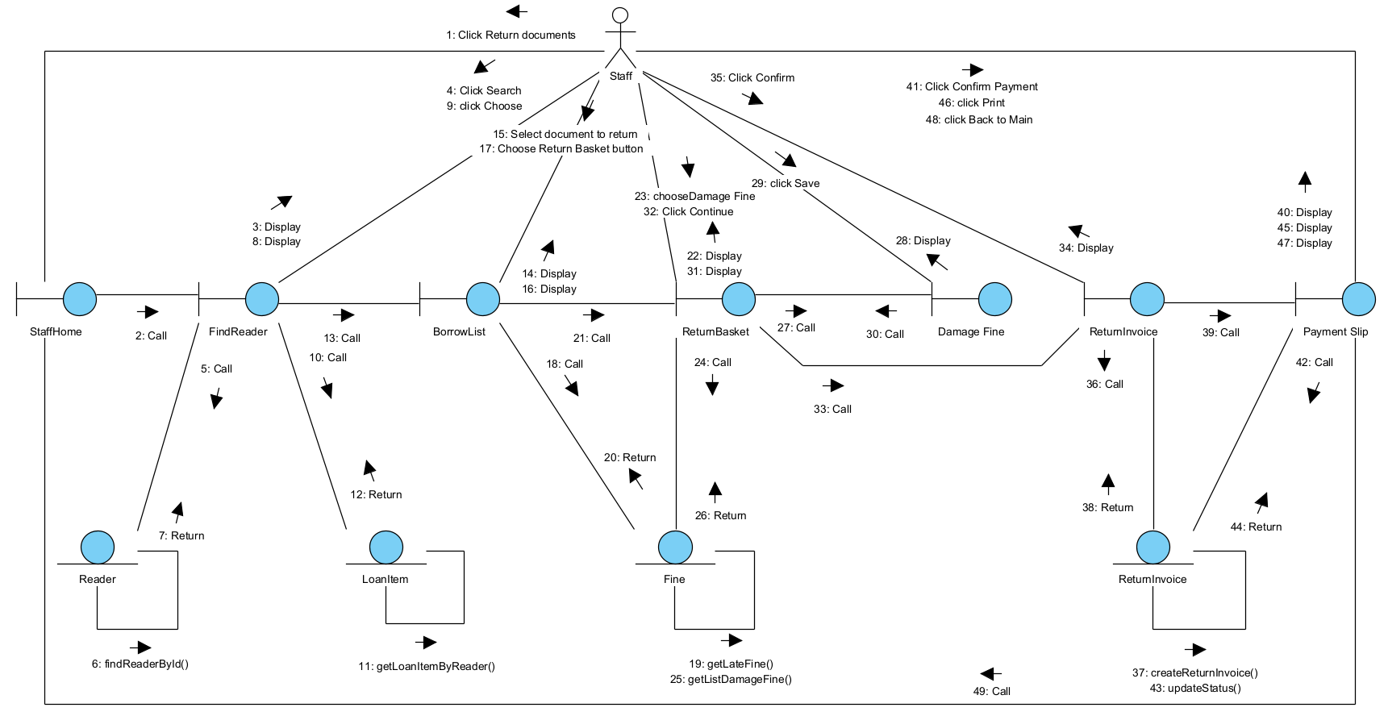

Figure 2.7. Communication Diagram for the “Reader Return Document” Modul

2.7. Draw the sequence diagram for the modul

2.7.1 Module “Reader Register as a Reader Card”
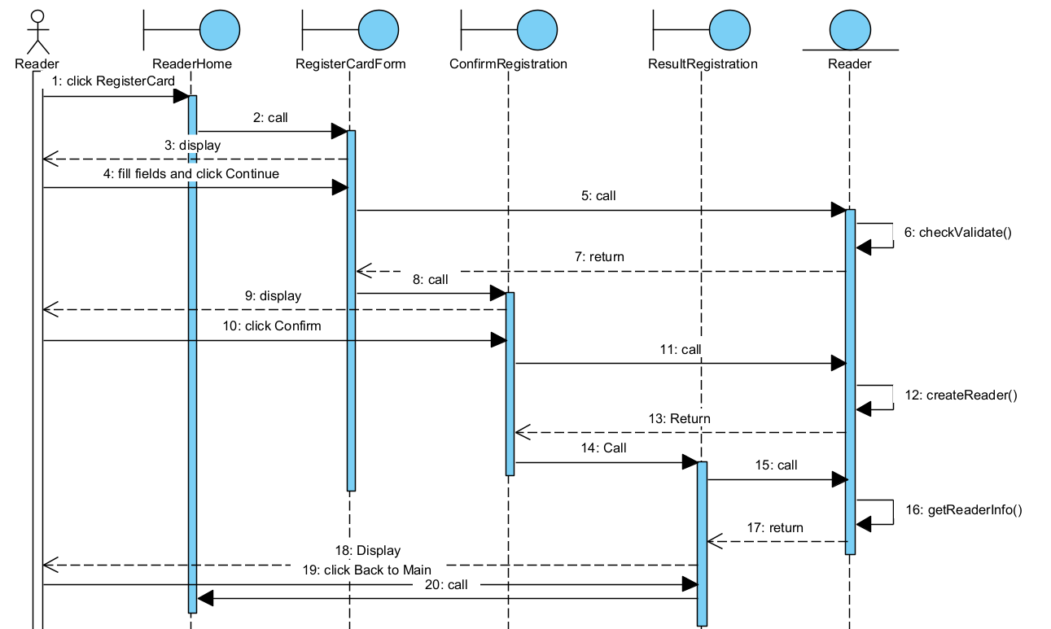

Figure 2.8. Sequence Diagram for the “Reader Register as a Reader Card” Modul

2.7.2 Module “Reader Returns Document”
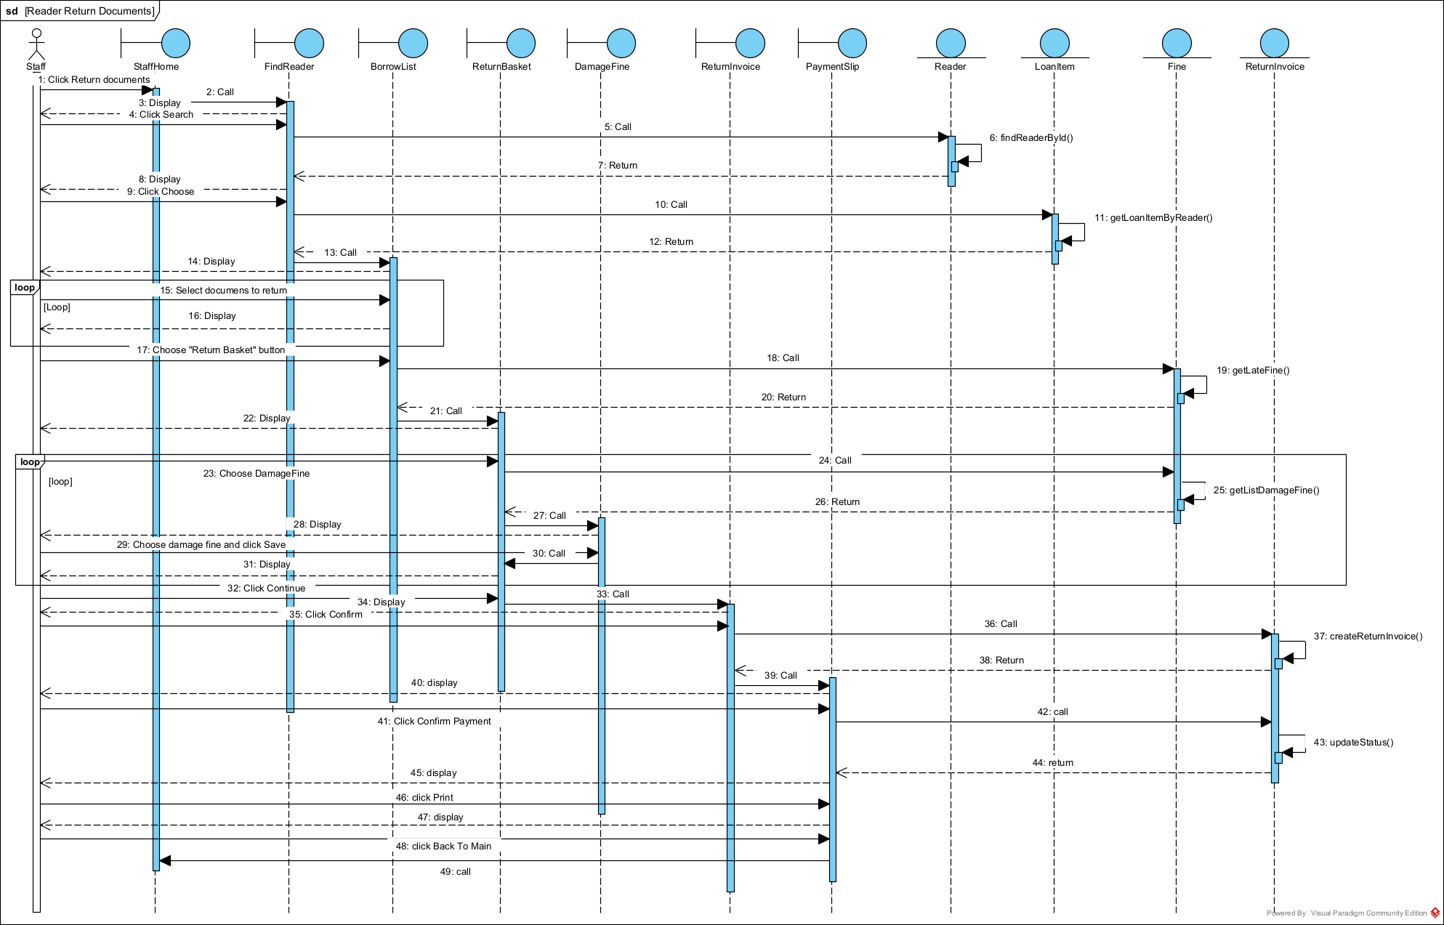

Figure 2.9. Sequence Diagram for the “Reader Returns Document” Module

Part 3: Design

3.Entity class diagram (design phase)
- Step 1: Supplementing the id Atribute:
  - Action: Supplement the id attibute to all classes, except for: Statistics classes
- Step 2: Supplementing Data types for the Attributes
  - Action: Supplement data types for the attributes of all classes according to the Java programming language
- Step 3: Converting association Relationship to Aggregation/Composition
  - Action: Convert the following associations relationships into Aggregation/Composition forms:
    - Loan – Copy via LoanItem: the relationship is converted so that Loan composes LoanItem, and LoanItem composes Copy
    - ImportInvoice – Copy via ImportItem: the relationship is converted so that ImportInvoice composes ImportItem, and LoanItem composes Copy
    - ReturnItem – Fine via FineDetail: the relationship is converted so that ReturnItem composes FineDetail, and FineDetail composes Fine
- Step 4: Supplementing Entity Class object Attributes
  - Action: Splement the component attribute for the Aggregation/Composition relationships. We obtain the entit class design diagram as shown below;
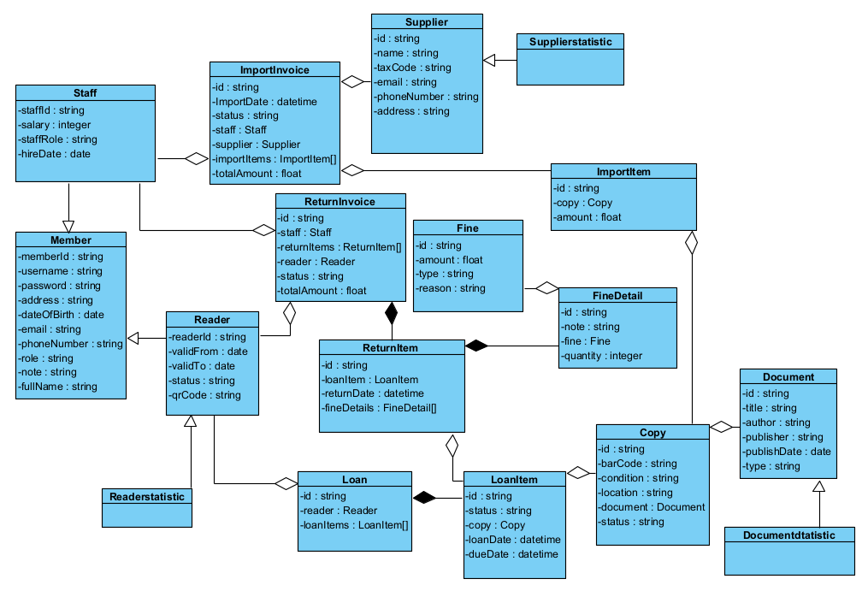

Figure 3.1. Entity Class Diagram (Design Phase)

3.2. Database design for the entire system
Step 1: Entity Class to Table Mapping
- Class Member -> table tblMember
- Class Reader -> table tblReader
- Class Staff -> table tblStaff
- Class Document -> table tblDocument
- Class Copy -> table tblCopy
- Class Loan -> table tblLoan
- Class LoanItem -> table tblLoanItem
- Class Supplier -> table tblSupplier
- Class ImportInvoice -> table tblImportInvoice
- Class ImportItem -> table tblImportItem
- Class ReturnInvoice -> table tblReturnInvoice
- Class ReturnItem -> table tblReturnItem
- Class Fine -> table tblFine
- Class FineDetail -> table tblFineDetail
- Class StatiscalReports
Step2: Transfer Non-Object Attributes of the Entity Class to the Corresponding Table Attributes
- tbleMember: memberid, username, password, address, dateofbirth, email, phonenumber, role, note, fullname
- tblStaff: staffid, salary, staffrole, hiredate
- tblSupplier: id, name, taxCode, email, phonenumber, address
- tblDocument: id, title, author, publisher, publishdate, type
- tblCopy: id, barcode, condition, location
- tblImportInvoice: id, importdate, status
- tblImportItem: id, amount
- tblReader: readerid, validfrom, validto, status, qrcode
- tblLoan: id
- tblLoanItem: id, loandate, duedate
- tblReturnInvoice: id, status
- tblReturnItem: id, returndate
- tblFine: id, amount, type, reason
- tblFineDetail: id, note
Step 3: Relationship Conversion (Cardinality)
- 1 tblMember – 1 tblStaff
- 1 tblMember – 1 tblReader
- 1 tblReader – n tblLoan
- 1 tblReader – n tblReturnInvoice
- 1 tblStaff – n tblImportInvoice
- 1 tblStaff – n tblReturnInvoice
- 1 tblSupplier – n tblImportInvoice
- 1 tblDocument – n tblCopy
- 1 tblCopy – 1 tblImportItem
- 1 tblCopy – n tblLoanItem
- 1 tblLoan – n tblLoanItem
- 1 tblImportInvoice – n tblImportItem
- 1 tblReturnInvoice – n tblReturnItem
- 1 tblLoanItem – 1 tblReturnItem
- 1 tblFine – n tblFineDetail
- 1 tblReturnItem – n tblFineDetail
Step 4: Key Attribute: AssignmentSupplementing Key Attributes: The Primary Key is set to the id attribute of the corresponding tables.
Step 5: Derived Attributes
- Status in tbleLoan
- totalAmount in tblImportInvoice
- totalAmount in tblReturnInvoice
- quantity in FineDetail

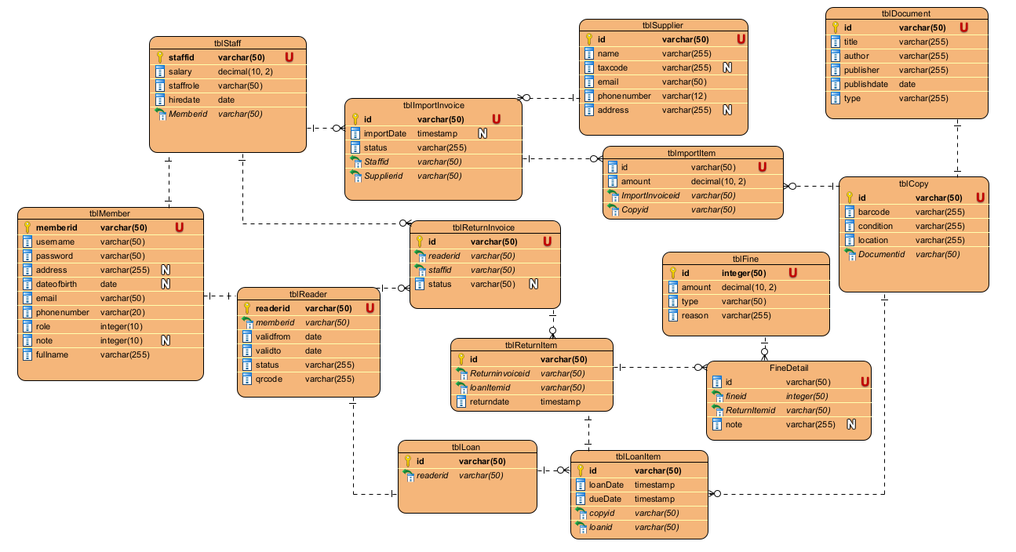

3.2. Database Diagram

3.3. draw the class diagram for the module

3.3.1. Module “register as a reader card”
- The interface layer has JSP pages: ReaderHome, RegisterCardForm, ConfirmRegistration, ResultRegistration
- The protocol layer has controller classes: ReaderController
- The data handling layer DAO classes: ReaderDAO
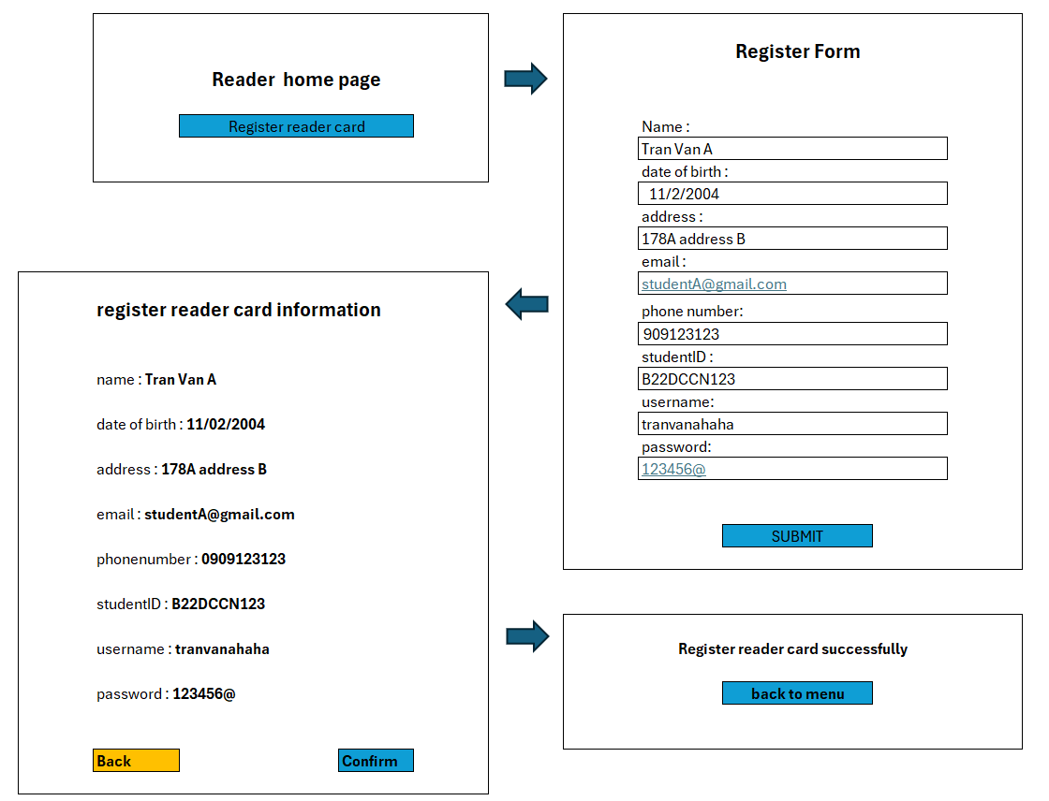
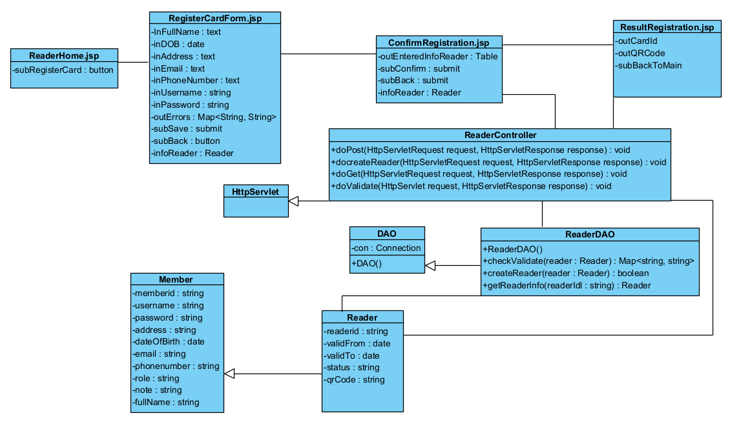

Figure 3.3. Class Diagram for the “Reader Card Registration” Module (DesignPhase)

3.3.2. Design module return documents:
- The interface layer has JSP pages: StaffHome, FindReader, BorrowList, ReturnBasket, DamageFine, ReturnInvoice, PaymentSlip
- The protocol layer has controller classes: ReaderController, LoanItemController, FineController, ReturnInvoiceController
- The data handling layer DAO classes: readerDAO, LoanItemDAO, FineDAO, ReturnInvoiceDAO
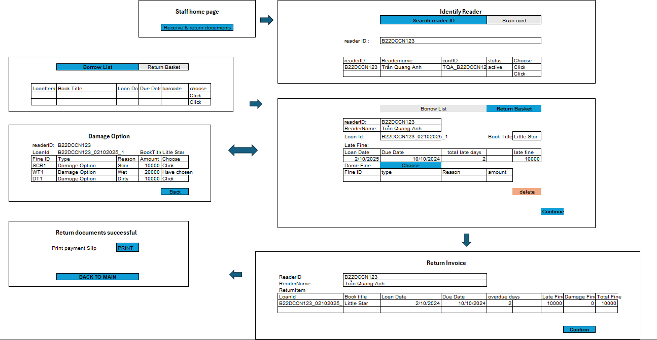
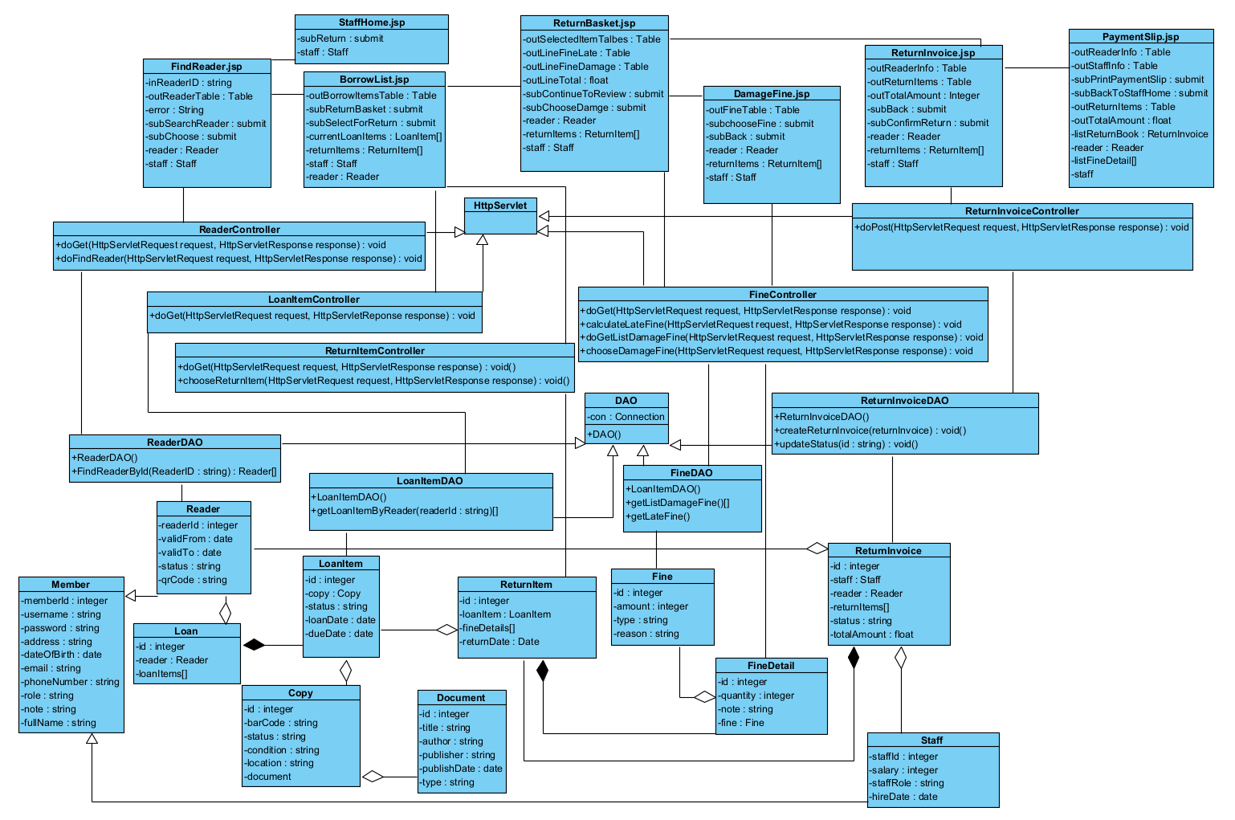

Figure 3.4. Class Diagram for the “Reader Return Documents” Modul (Design Phase)

3.4. Design activity diagrams for the modul

3.4.Modul “Register as a reader card”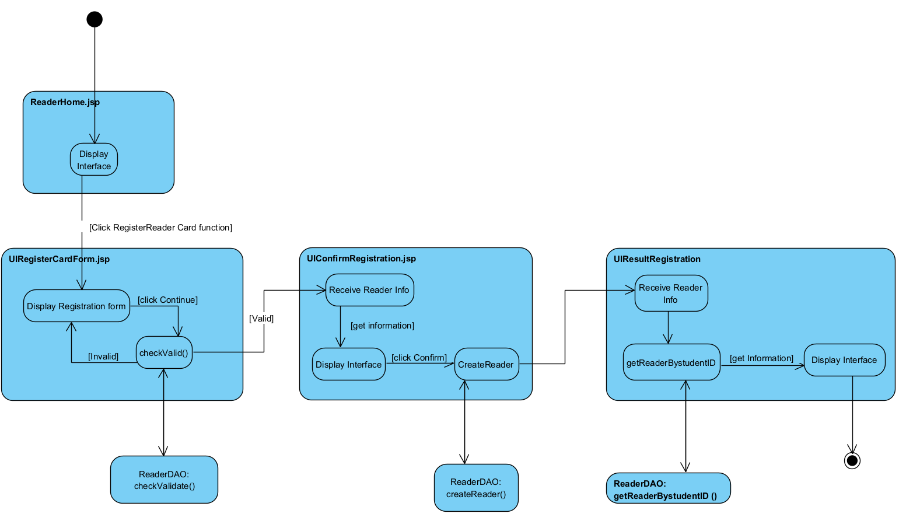

Figure 3.5 Activity Diagram for the “Register as a reader card” modul

3.4.2 modul “Reader return documents”
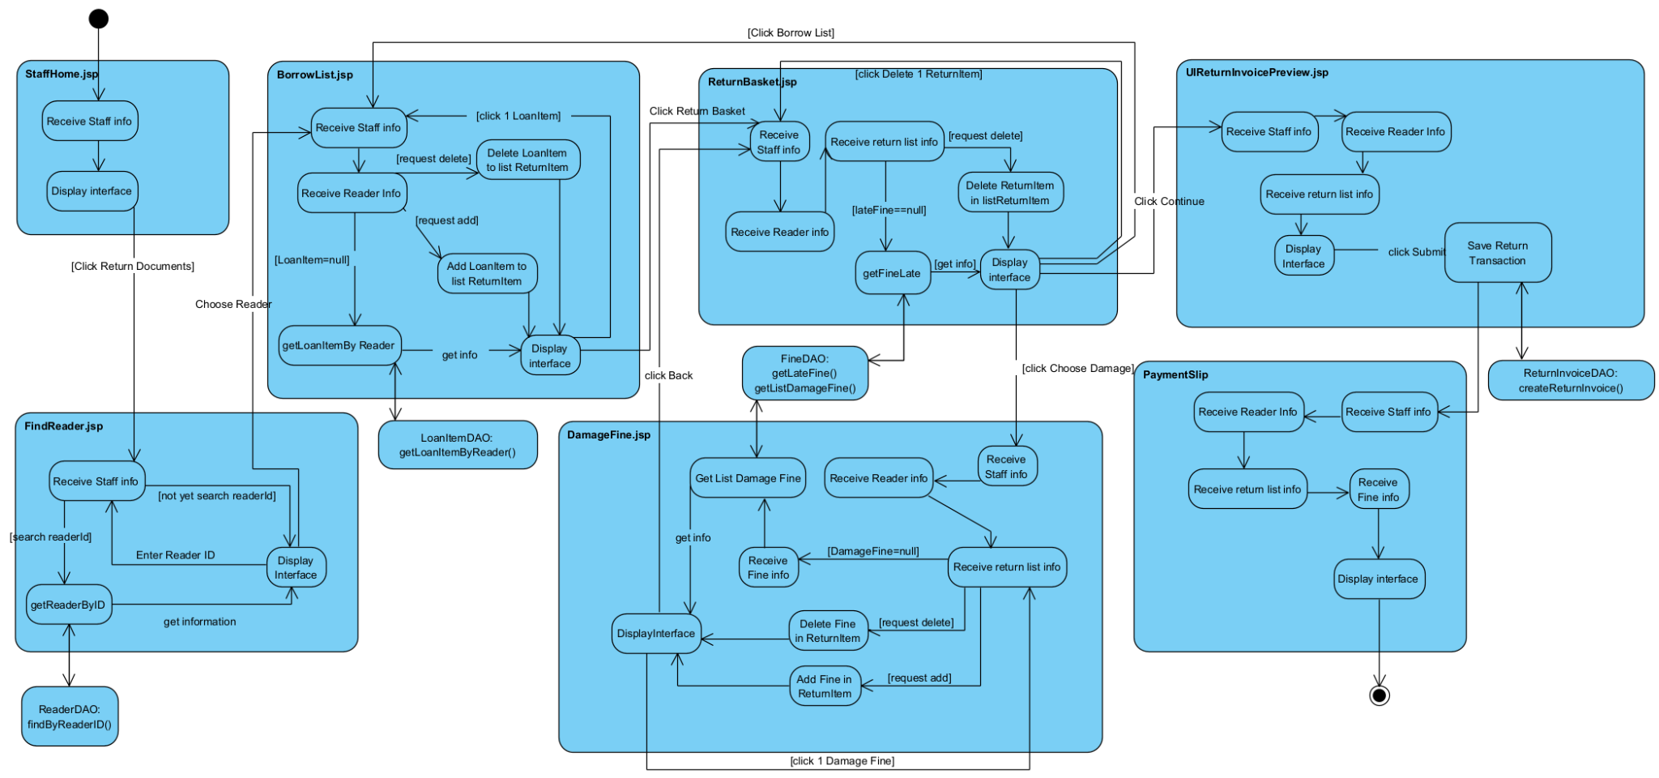

Figure 3.6 Activity Diagram for the “Reader return documents” modul

3.5. Scenario 3.0

3.5.1. modul “Register as a reader card”
- At the reader's main interface, the reader clicks Card Registration.
- Page ReaderHome.jsp calls page RegisterCardForm.jsp.
- Page RegisterCardForm.jsp displays to the reader.
- The reader enters information and click Continue.
- Page RegisterCardForm.jsp calls ReaderController.
- ReaderController performs doPost.
- ReaderController calls Reader.
- Reader entity package the entity information.
- Reader returns the result to ReaderController.
- ReaderController calls ReaderDAO.
- ReaderDAO call method checkValidate()
- ReaderDAO returns the result to ReaderController.
- ReaderController calls page ConfirmRegistration.jsp.
- Page ConfirmRegistration.jsp displays to the reader.
- The reader clicks Submit.
- Page ConfirmRegistration.jsp calls ReaderController.
- ReaderController performs doPost.
- ReaderController calls ReaderDAO.
- ReaderDAO calls method createReader().
- ReaderDAO returns the result to ReaderController.
- ReaderController calls ReaderDAO.
- ReaderDAO calls getReaderInfo()
- ReaderDAO calls Reader.
- Reader entity package the entity information.
- Reader returns the result to ReaderDAO.
- ReaderDAO returns the result to ReaderController.
- ReaderController returns the result to ResultRegistration.jsp.
- Page ResultRegistration.jsp displays to the reader.
- The reader clicks Back to Main.
- Page ResultRegistration.jsp calls page ReaderHome.jsp.

3.5.2. modul “Reader return documents”
- At the StaffHome.jsp, the staff clicks Return Documents.
- StaffHome.jsp calls FindReader.jsp.
- FindReader.jsp display to the staff
- staff search reader id
- BorrowList.jsp calls ReaderController.
- ReaderController calls doGet()
- ReaderController calls ReaderDAO.
- readerDAO call methods findReaderById()
- findReaderById() calls Reader.
- Class Reader packages the entity information.
- Reader returns the result to method findReaderById()
- ReaderDAO returns the result to ReaderController.
- ReaderController returns to FindReader.jsp
- FindReader.jsp display to the staff
- Staff choose reader.
- FindReader.jsp call LoanItemController
- LoanItemController call methods doGet()
- LoanItemController calls LoanItemDAO.
- LoanItemDAO call method getLoanItemByReader()
- getLoanItemByReader() call LoanItem.
- Class LoanItem packages the entity information.
- LoanItem returns the result to method getLoanItemByReader().
- LoanItemDAO returns the result to LoanItemController.
- LoanItemController returns the result to BorrowList.jsp.
- BorrowList.jsp displays the borrowed list to the staff.
- The staff select documents to return.
- BorrowList.jsp calls ReturnItemController.
- ReturnItemController call method doGet()
- ReturnItemController call ReturnItem
- ReturnItem package entity information
- ReturnItem return to ReturnItemController
- ReturnItemController return to BorrowList.jsp
- BorrowList.jsp display to the staff.
- The staff chooses Return Basket.
- BorrowList.jsp call FineController.
- FineController calls method doGet()
- FineController calls FineDAO.
- FineDAO call methods getLateFine()
- getLateFine() calls Fine.
- Class Fine packages the entity information
- Fine returns the result to FineDAO.
- FineDAO returns the result to FineController.
- FineController call FineDetail
- FineDetail package entity information
- FineDetail return to FineController
- FineController returns the result to ReturnBasket.jsp.
- ReturnBasket.jsp displays the item being returned and Overdue Fine to staff.
- The staff chooses Damage.
- ReturnBasket.jsp calls FineController.
- FineController performs doGet.
- FineController calls FineDAO.
- FineDAO call getListDamageFine()
- getListDamageFine() calls Fine.
- Class Fine packages the entity information
- Fine returns the result to FineDAO.
- FineDAO returns the result to FineController.
- FineController call to DamgeFine.jsp.
- DamageFine.jsp displays the Damage Fine Selector to staff.
- The staff selects damage Fine.
- DamageFine.jsp calls FineController.
- FineController call doGet().
- FineController call FineDetail
- FineDetail package entity information
- FineDetail return to FineController
- FineController return the results to DamageFine.jsp.
- DamageFine.jsp display to staff
- staff choose Save
- DamageFine.jsp calls ReturnBasket.jsp
- ReturnBasket.jsp display to the staff
- The Staff click contrinue
- ReturnBasket.jsp calls ReturnInvoice.jsp.
- ReturnInvoice.jsp displays the Invoice Preview to staff.
- The staff clicks Confirm.
- ReturnInvoice.jsp calls ReturnInvoiceController.
- ReturnInvoiceController performs doPost()
- ReturnInvoiceController calls ReturnInvoice
- ReturnInvoice package the entity information.
- ReturnInvoice return the results to ReturnInvoiceController
- ReturnInvoiceController calls ReturnInvoiceDAO.
- ReturnInvoiceDAO call method createReturnInvoice()
- ReturnInvoiceDAO returns the result to ReturnInvoiceController.
- ReturnInvoiceController call the result to PaymentSlip.jsp.
- PaymentSlip.jsp displays the payment slip to staff.
- Staff click ConfirmPayment.
- PaymentSlip call ReturnInvoiceController
- ReturnInvoiceController call doPost()
- ReturnInvoiceController call ReturnInvoiceDAO
- ReturnInvoiceDAO call updateStatus()
- ReturnInvoiceDAO return the result to ReturnInvoiceController
- ReturnInvoiceController return to PaymentSlip
- PaymentSlip display to staff.
- The staff clicks Print.
- PaymentSlip.jsp displays the payment slip.
- The staff clicks Back to Main.
- ReturnInvoice.jsp calls StaffHome.jsp.

3.6. Design sequence diagrams for the modul

3.6.1. modul “Reader Register as a Reader Card”
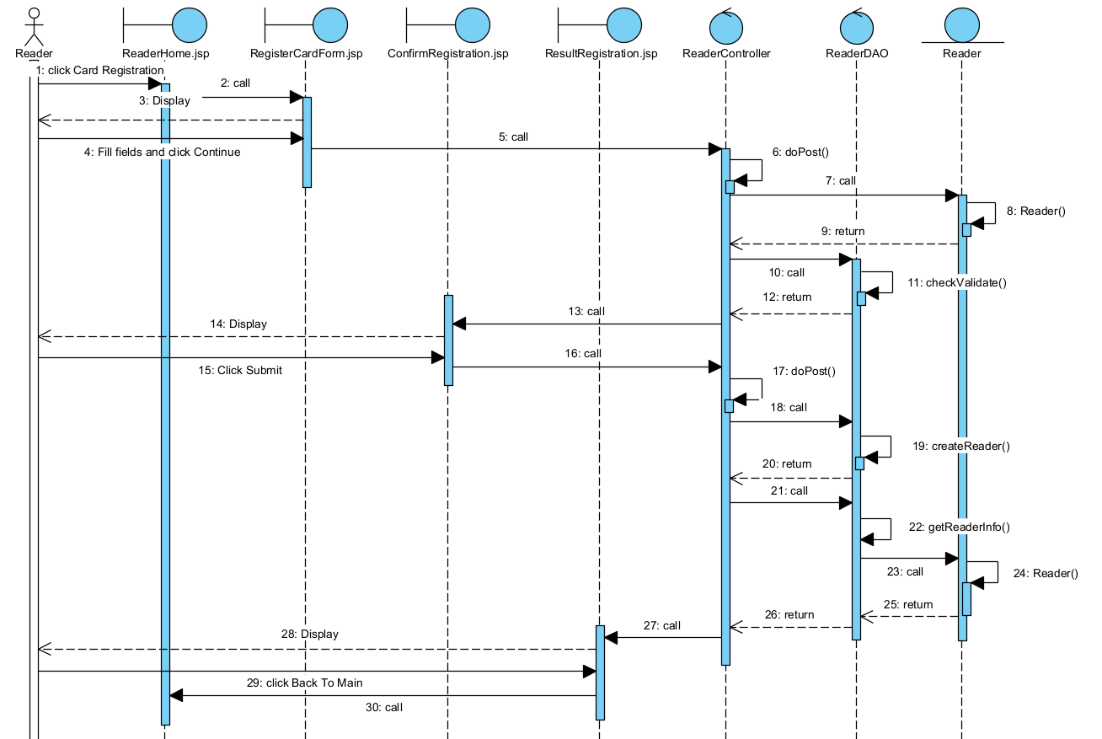

Figure 3.7. Sequence Diagram for the “Reader Register as a reader card” modul

3.6.2. modul “Reader return documents”
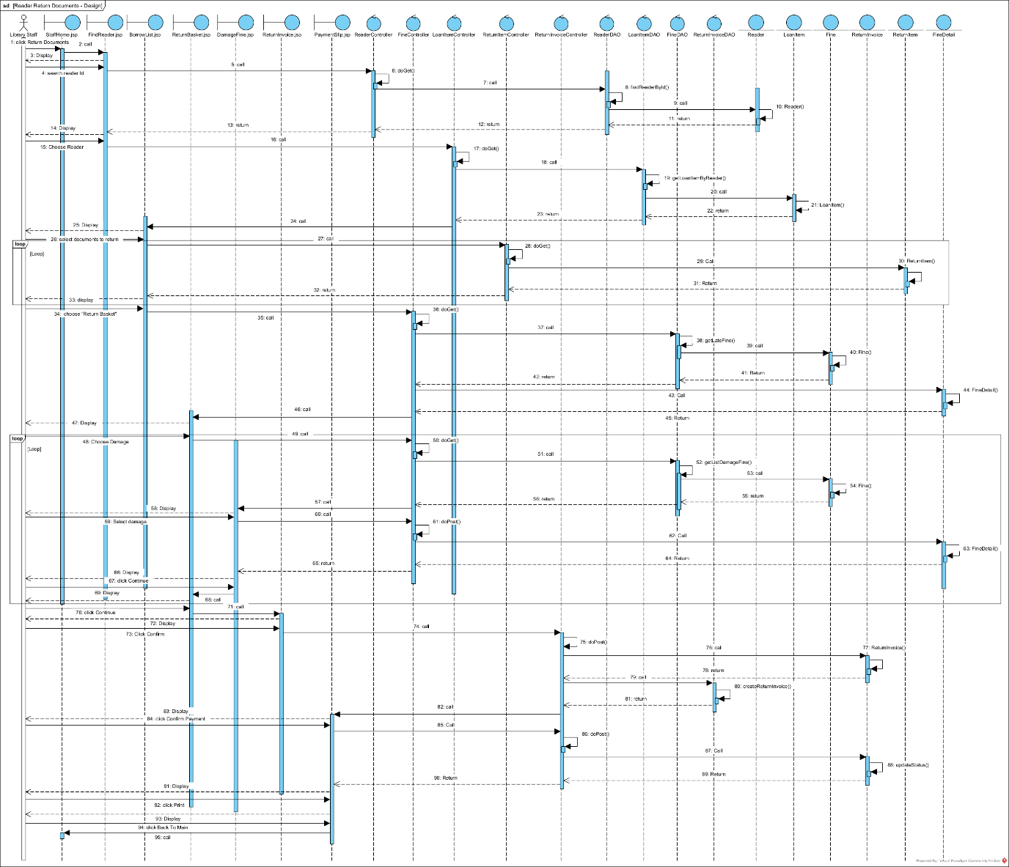

Figure 3.8. Sequence Diagram for the “Reader return documents” modul

3.7 Design Package diagram of the system
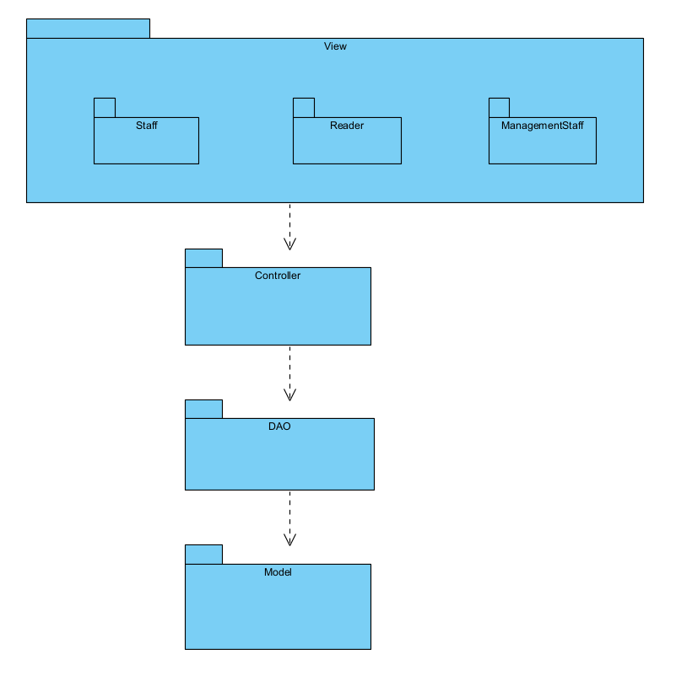

Figure 3.9. Package Diagram

3.8 Design Deployment Diagram of the system
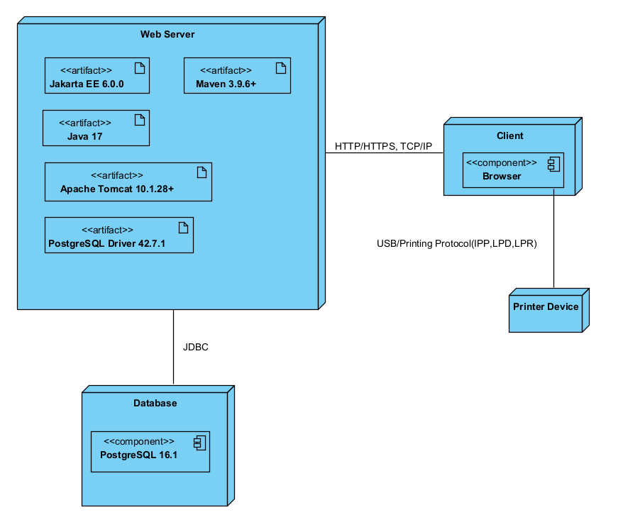

Figure 3.10. Deployment Diagram

Part 4: Coding

4.1 project organization
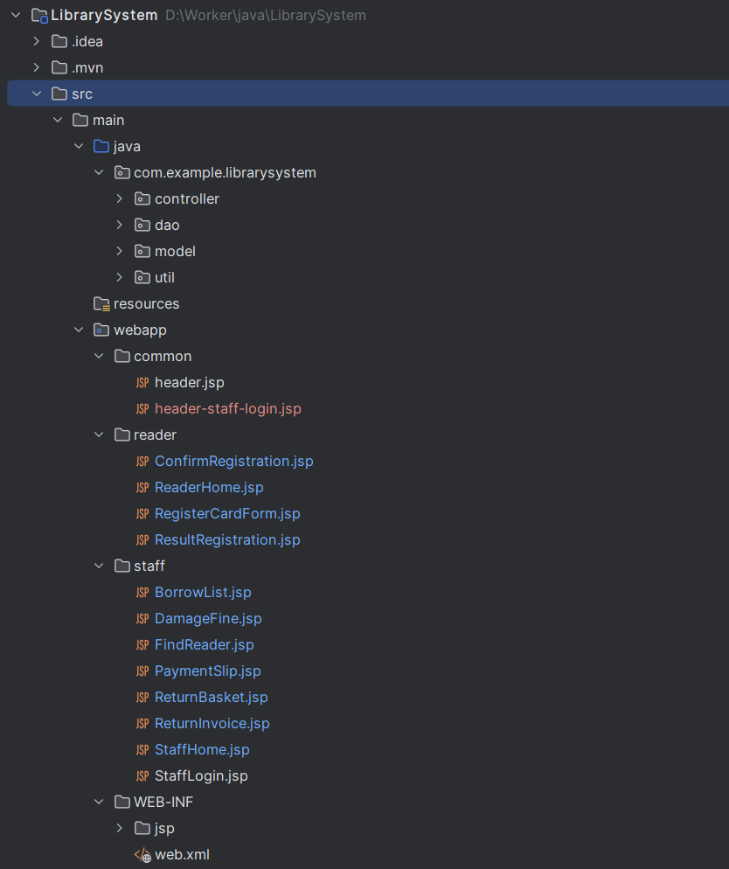

4.2 Interface Image

4.2.1 Modul “Reader Register a Reader Card”
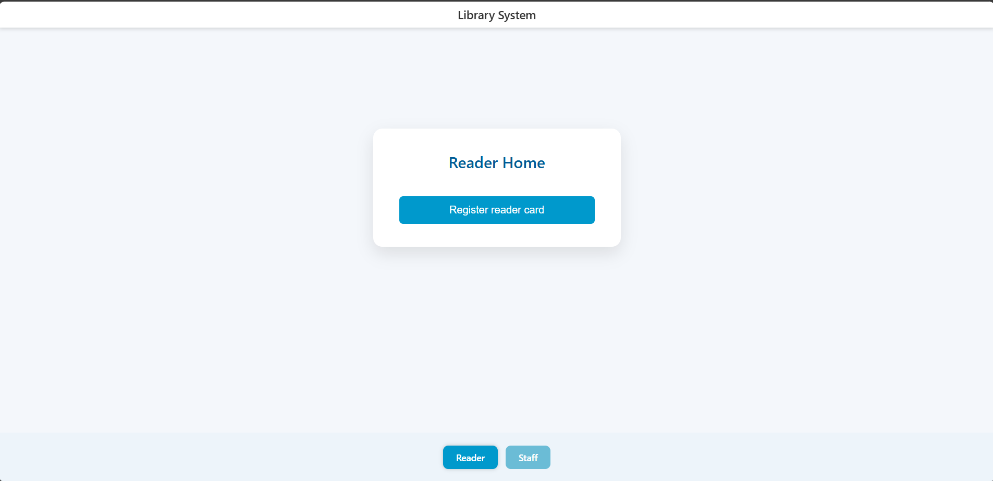
Reader Home interface
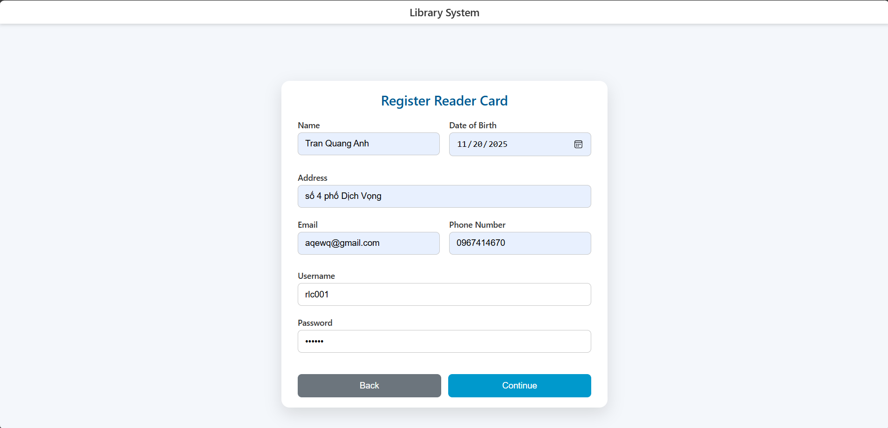
Register Card Form interface
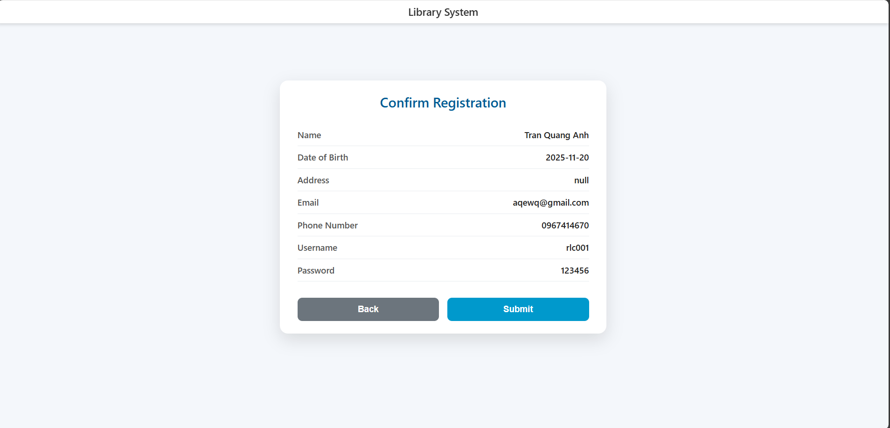
Confirm Registration interface
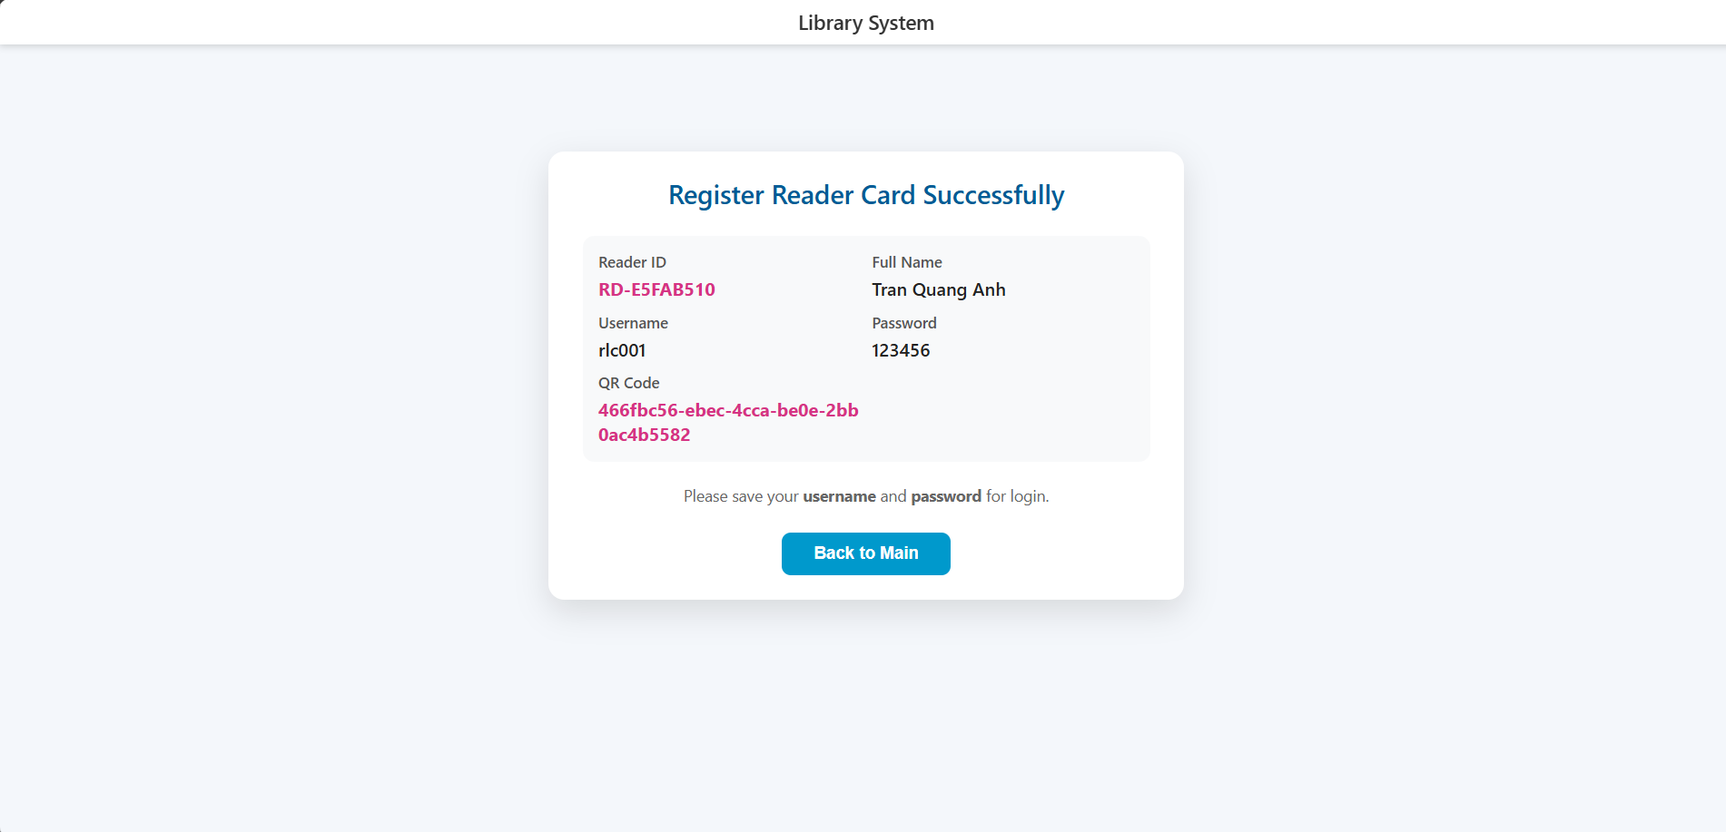
Result Registration interface

4.2.2 Modul “Reader Return Documents”
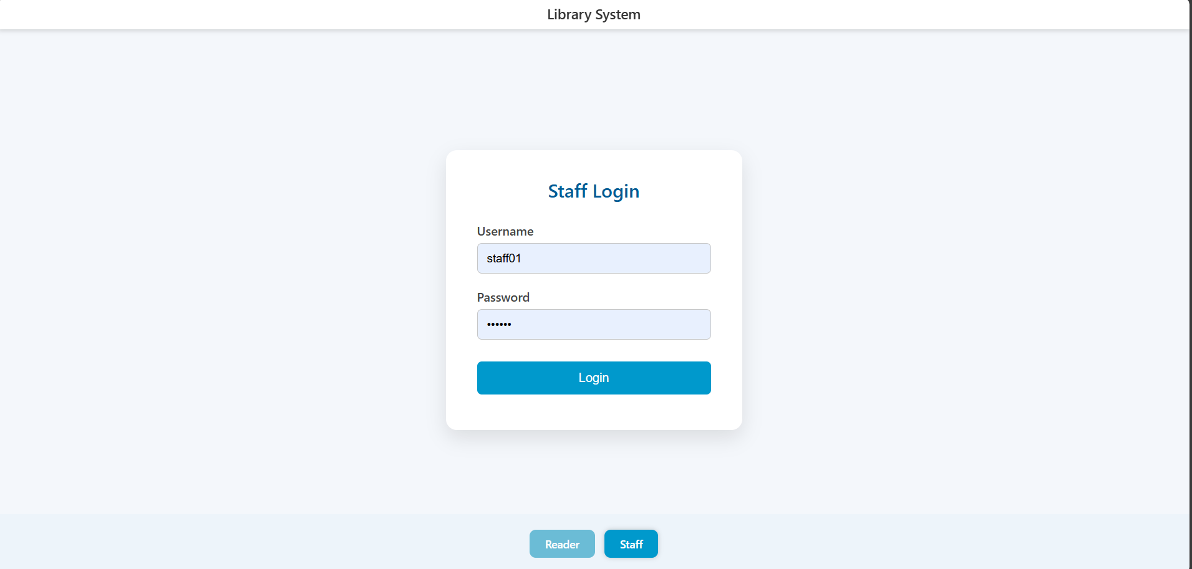
Staff Login interface
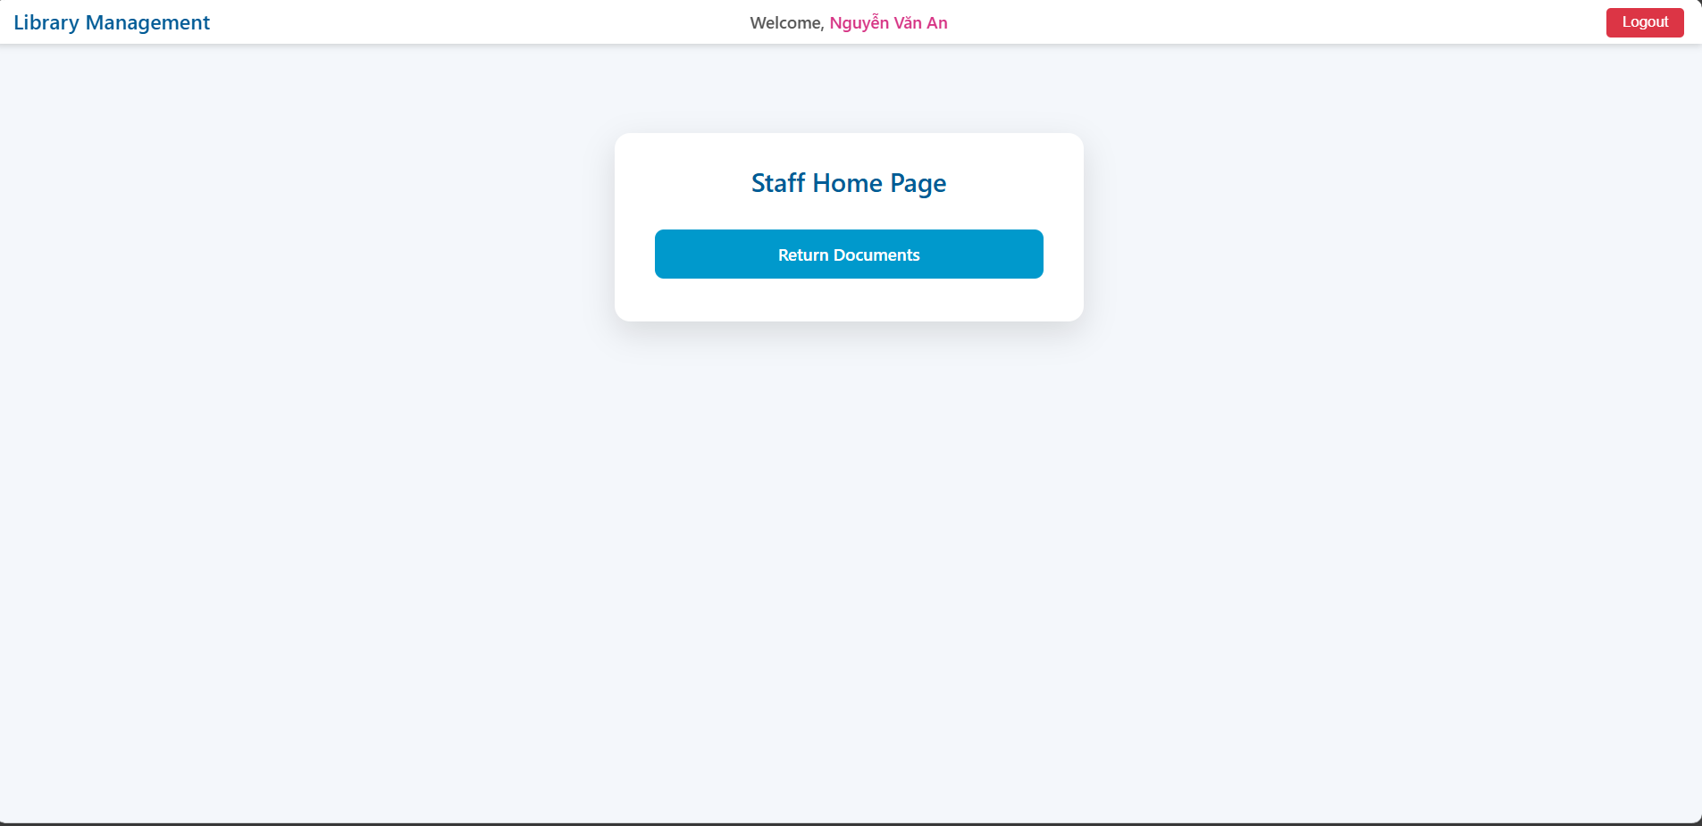
Staff home interface
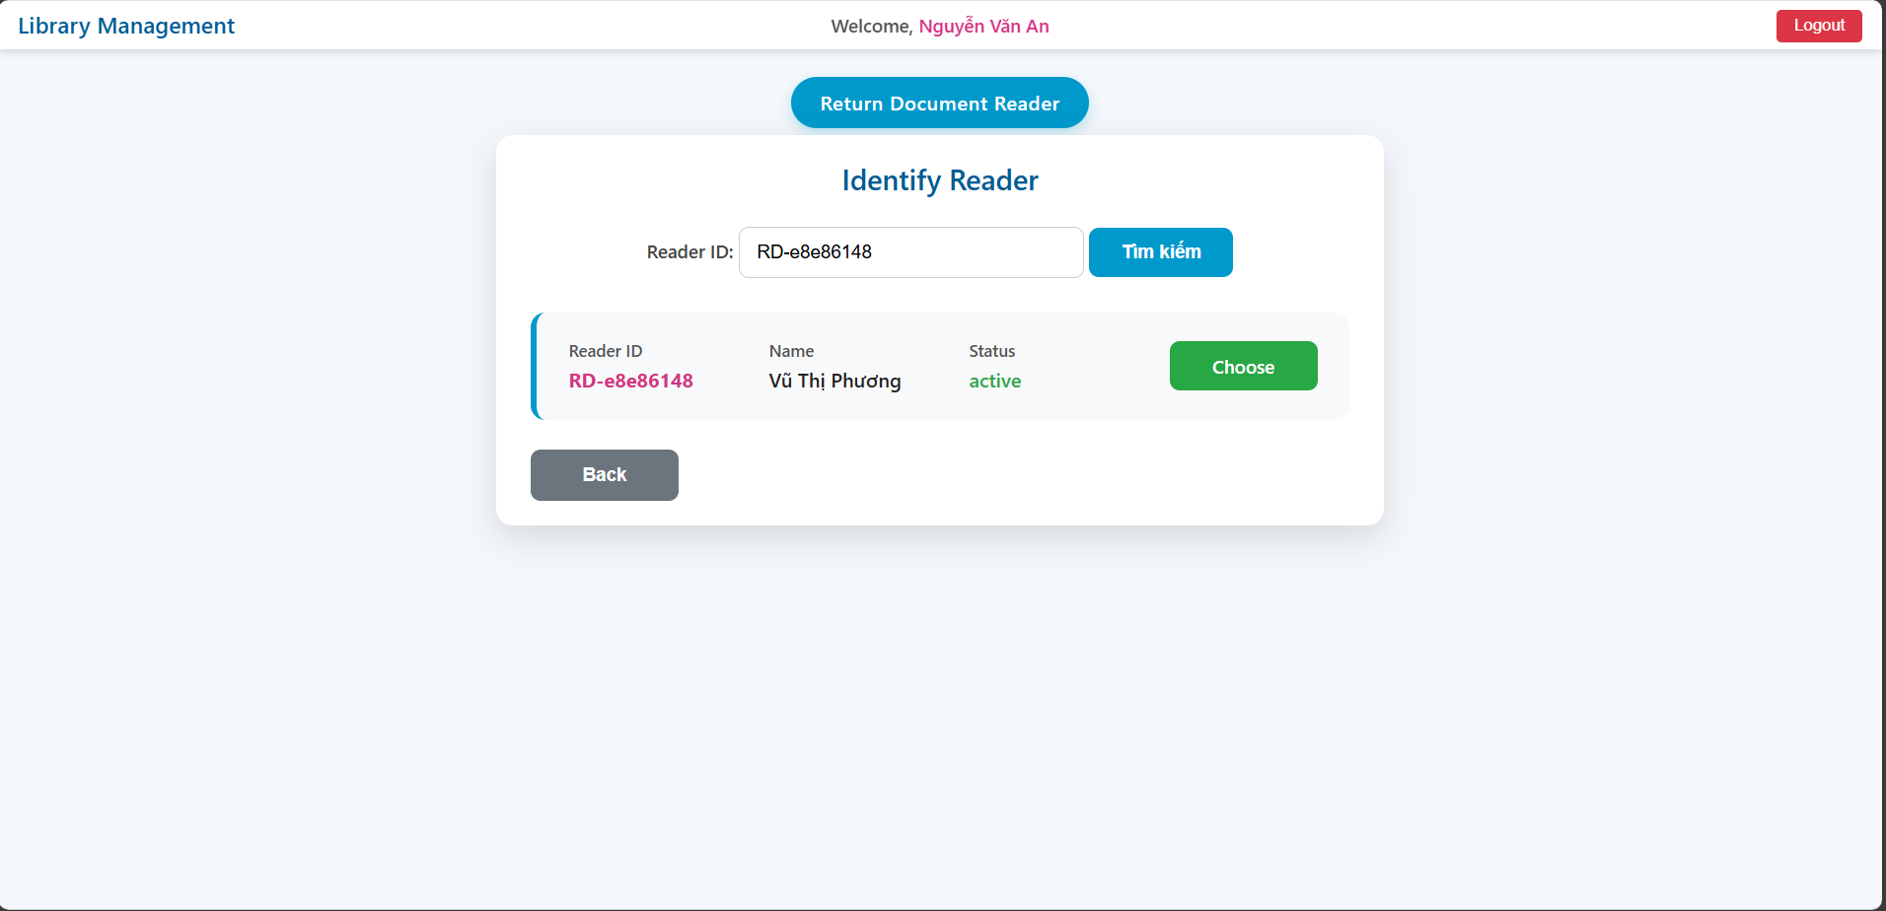
Find Reader interface
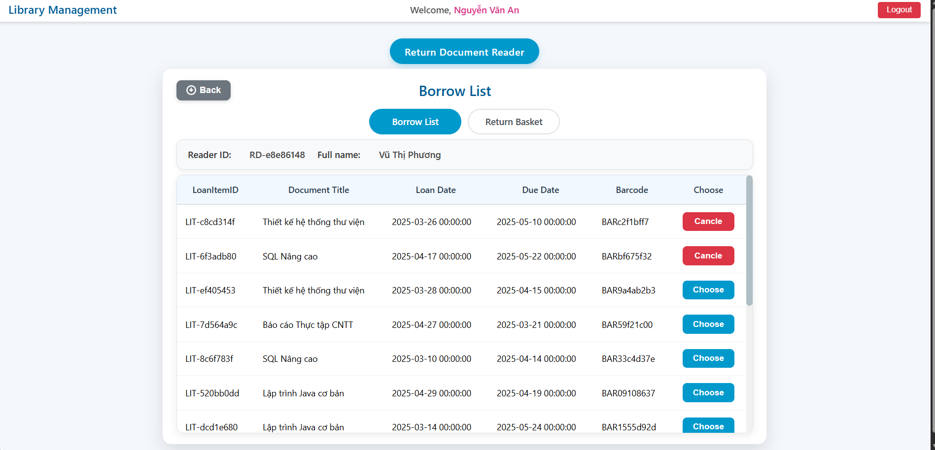
Borrow List interface
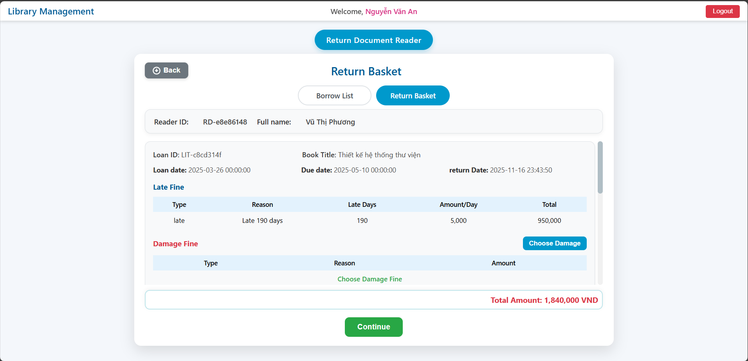
Return Basket interface
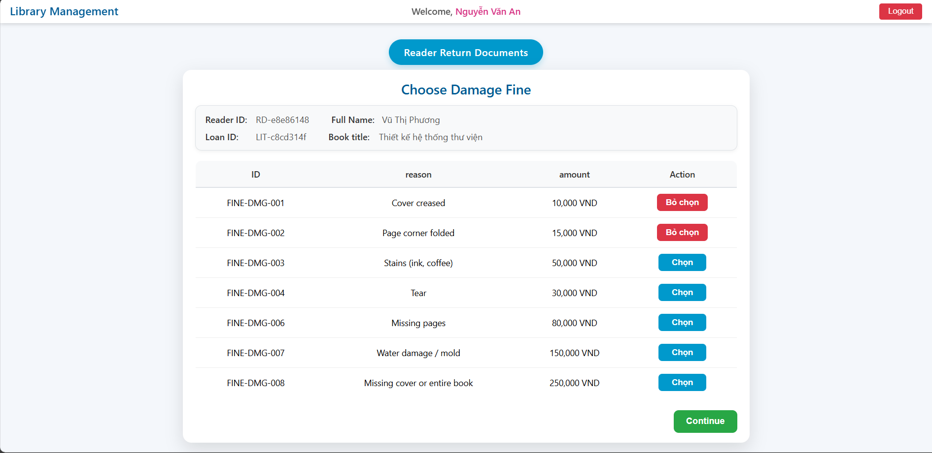
Damage Fine interface
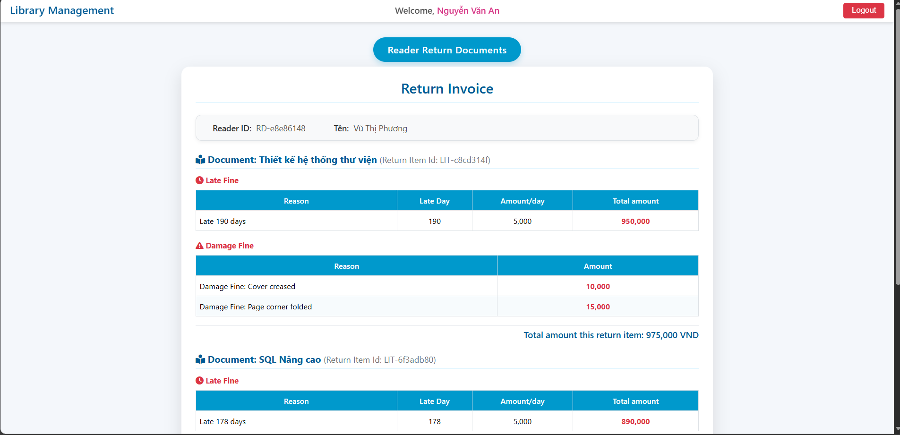
Return Invoice interface
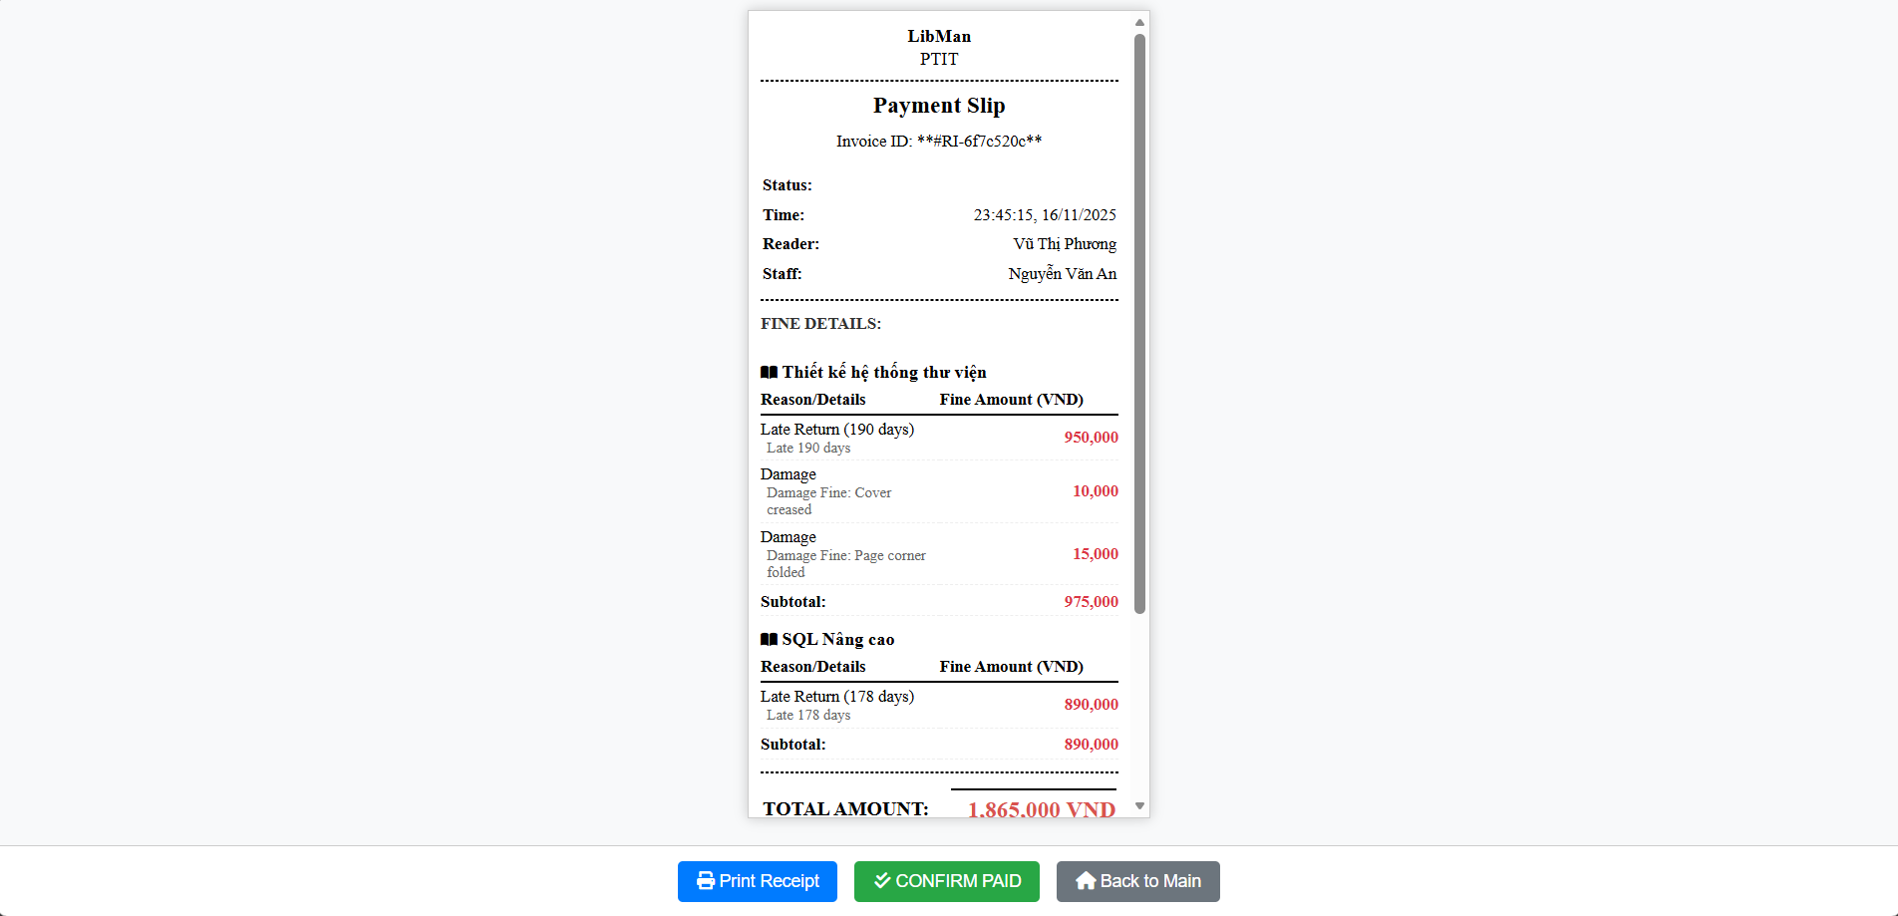
Payment Slip interface

Source code: TranQuanh/book-library-management

